# Sonar

Sonar is a code quality analysis tool. It features:

* Static code analysis for 15 languages
* Detect bugs & vulnerabilities
* CI/CD Integration

Local installation:

* Download zip package
* Extract it to local location
* Launch sonar server by triggering StartSonar.bat file from bin/windows-x86-64

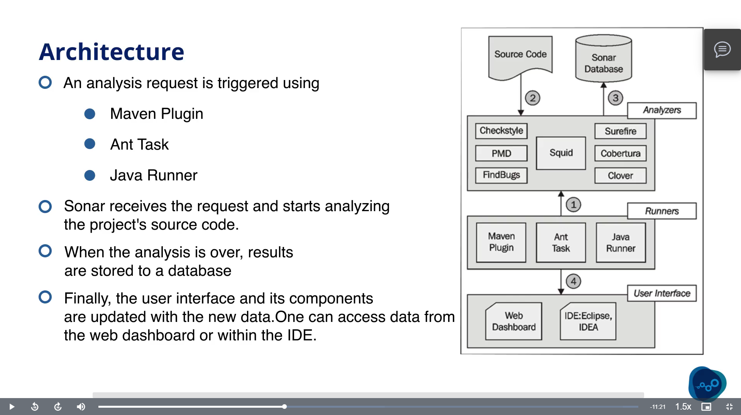

* SonarQube is designed to analyse the source code and not the class files.
* It needs .project file in project folder to analyse the source code.

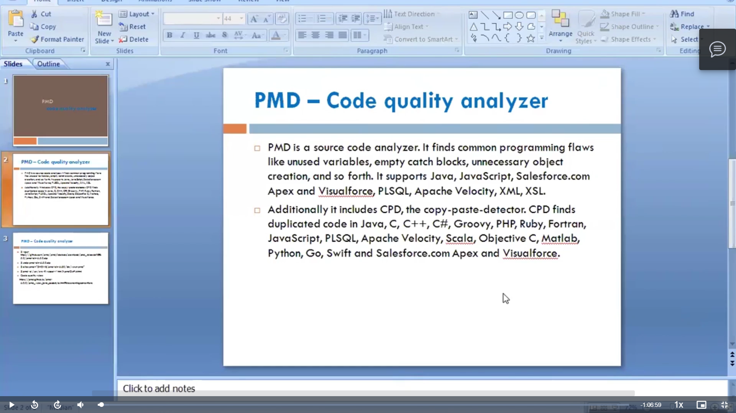

Process to use sonarqube:

1. Start StartSonar.bat file from bin
2. Open <http://localhost:9000\>
3. Generate a token
4. Give your programming language & build technology
5. Execute the SonarQube Scanner for Maven from your computer

Running a SonarQube analysis with Maven is straighforward. You just need to run the following command in your project's folder.

mvn sonar:sonar \

-Dsonar.host.url=http://localhost:9000 \

-Dsonar.login=f654386179e59c7d90e7af51252700326e6f9f56

Please visit the [official documentation of the SonarQube Scanner for Maven](http://redirect.sonarsource.com/doc/install-configure-scanner-maven.html) for more details.

1. Once the analysis is completed, you will be able to browse your project at the URL displayed at the end of the logs.

# Pagination

Pagination is helpful when we have a large dataset which needs to be presented in smaller chunks. This enhances performance, as not all the data is fetched at once from the backing Database (which overloads the processing), but only parts are fetched based on requirements.

Example: (Import Spring Data JPA Dependency)

|  |  |  |
| --- | --- | --- |
| **Student Entity:** @Entity  @Table(name="student")  public class Student {  @Id  @GeneratedValue  private Long id;  private String firstName;  private String lastName;  //Setters and getters  } | **Student Repository:** @Repository  public interface StudentRepository extends PagingAndSortingRepository<Student, Long> {} | **Pagination:** PageRequest Object (syntax)  Pageable paging = PageRequest.of(pageNo, pageSize); |

We can directly add PageRequest object with query in repository class.

Pageable firstTwoStudents = PageRequest.of(0, 2);

Page<Student> allStudents = studentRepository.findAll(firstTwoStudents);

Page<Student> allStudentsByFirstName = studentRepository.findAllByFirstName(“Rahul”,firstTwoStudents);

## **Sorting:**

Sort Object (syntax)

Sort sorting = Sort.by(“columnName”); // ascending by default

We can directly add Sort object with query in repository class:

Page<Student> students = studentRepository.findAll(Sort.by("firstName"));

Page<Student> students = studentRepository.findAll(Sort.by("lastName").descending());

Page<Student> students = studentRepository.findAll(Sort.by("firstName").and(Sort.by(“lastName”)));

## **Pagination and Sorting:**

PageRequest object supports passing of sorting object

Pageable pagingWithSorting = PageRequest.of(pageNo, pageSize, Sort.by(“columnName”));

Pageable sortedByfirstNameAsc = PageRequest.of(0, 3, Sort.by("firstName"));

Pageable sortedByLastNameDesc = PageRequest.of(0, 3, Sort.by("lastName").descending());

Pageable sortedByLastNameDescFirstNameAsc = PageRequest.of(0, 5, Sort.by("lastName").descending().and(Sort.by("firstName")));

Reference: <https://www.baeldung.com/spring-data-jpa-pagination-sorting> , <https://www.amitph.com/pagination-sorting-spring-data-jpa/>

# SQL

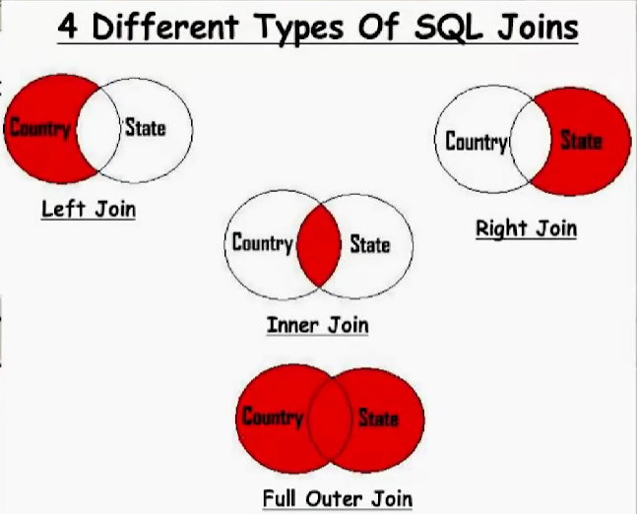

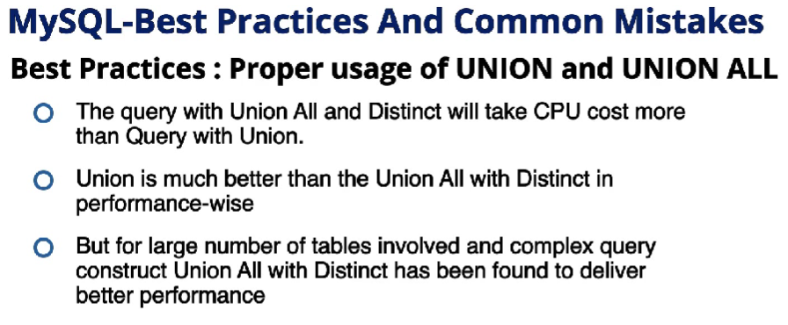

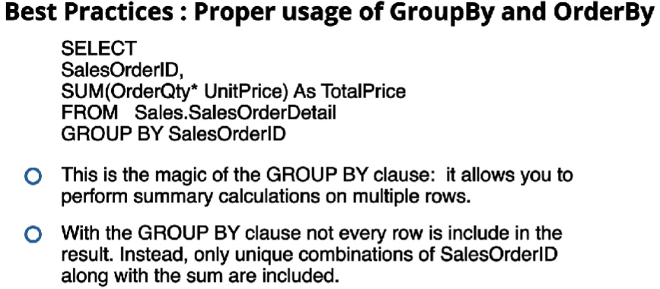

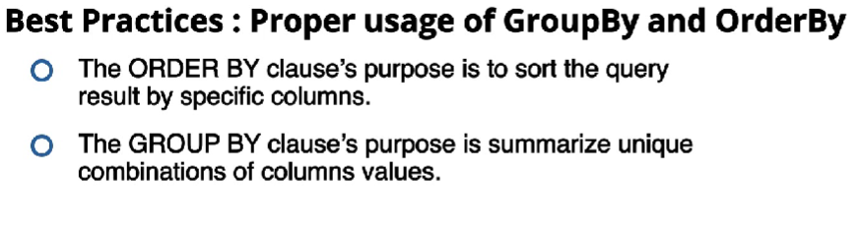

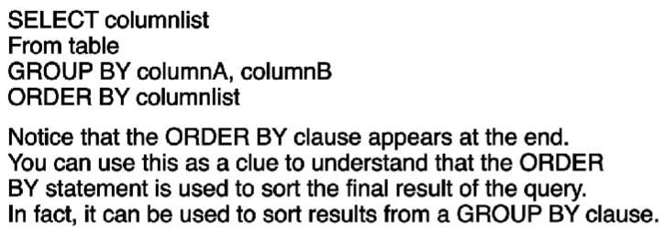

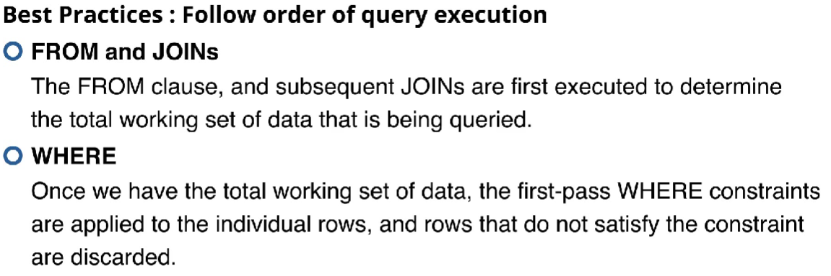

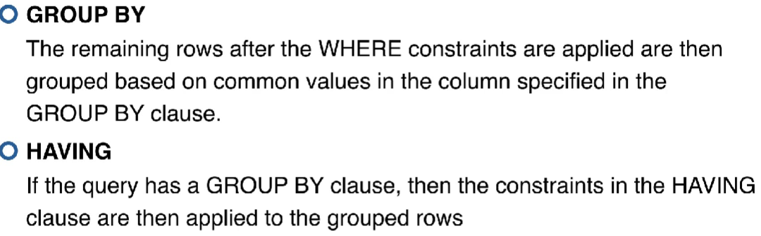

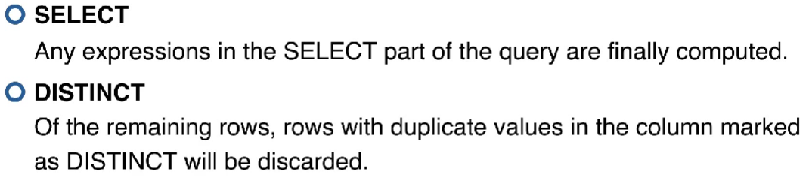

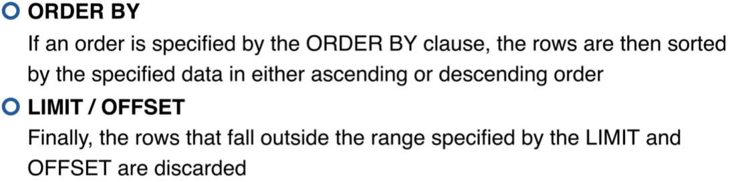

Order: F,J🡪W🡪G🡪H🡪S🡪D🡪O🡪L

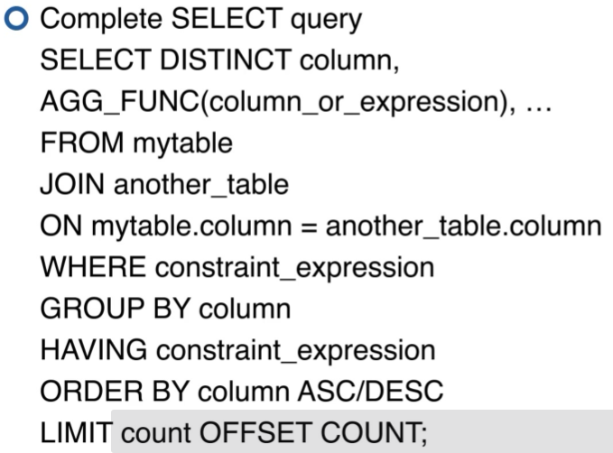

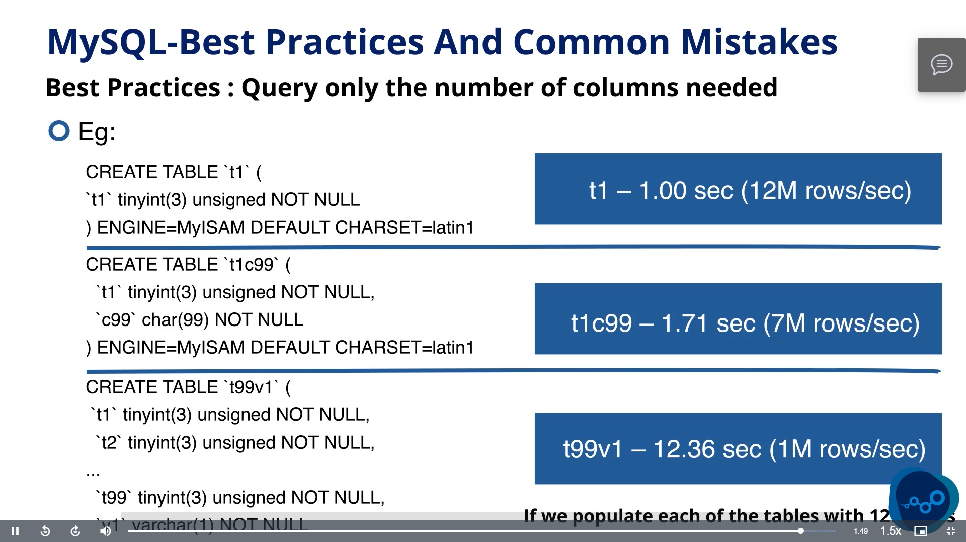

# MongoDB

* Relational DB(MySQL, PostGre, Oracle) store tables of data in columns and rows.
* NoSQL databases like MongoDB, we store our data in collections of documents.
* Documents are similar to Javascript objects or JSON objects.
* It supports BSON, similar to JSON with some added datatypes.
* Unlike relational DB, NoSQL DB don’t have strict data model like in relational DB when we create a table we have to insert data according to the data model of the table but here we don’t have to follow such rules.
* Advantages:
  + It is very scalable.
  + It’s fast.
  + It has built-in replication.
  + It can also scale horizontally, i.e., we can just add cheap machines to built up the cluster

# Spring Framework

* Support for infrastructure on application level:
  + Dependency injection
  + Aspect-oriented programming
* Spring provides plugin for
  + Testing
  + Data access
  + Web framework MVC and WebFlux
  + Integration

# Spring Boot

* Spring Boot follows convention over configuration paradigm
* It features standalone application.
* It has embedded tomcat server, so we don’t need to deploy our application in other server
* Provides starter dependencies to simplify build configuration.
* No requirement for writing xml configuration

Configuration methods:

* External: the application does not have to be prepared for different environments  
  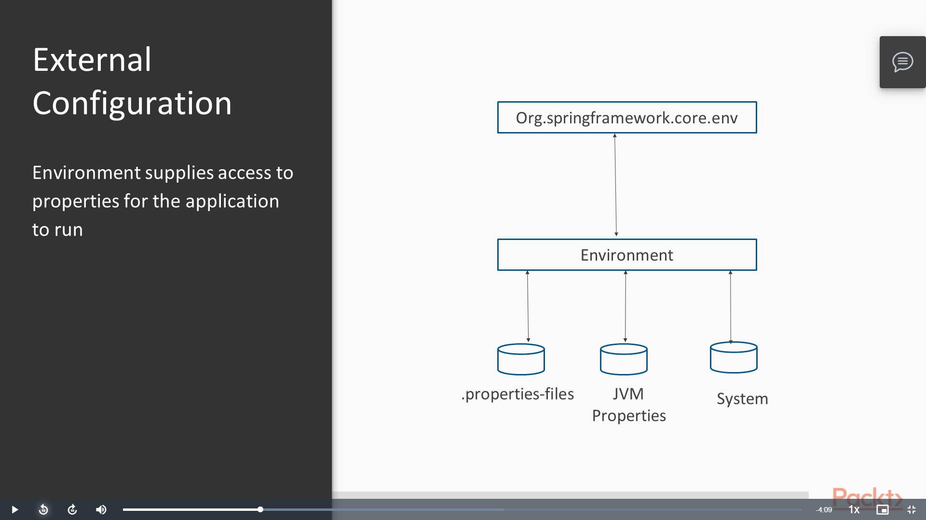

The following sources are processed in descending order to find properties:

1. Settings of DevTools in home directory
2. Properties of test bounded via @TestPropertySource
3. Properties of @SpringBootTest
4. Application parameter
5. System or environment variables SPRING_APPLICATION_JSON
6. ServletConfig params
7. ServletContext params
8. Java naming
9. Java system properties
10. OS system variables
11. Random value of namespace random
12. Application-{profile}.properties(outside of the artifact)
13. Application-{profile}.properties(inside of the artifact)
14. Application.properties(outside of the artifact)
15. Application.properties(inside of the artifact)
16. Properties loaded over @PropertySource of the configuration classes
17. Default properties set over the setDefaultProperties method of SpringApplication

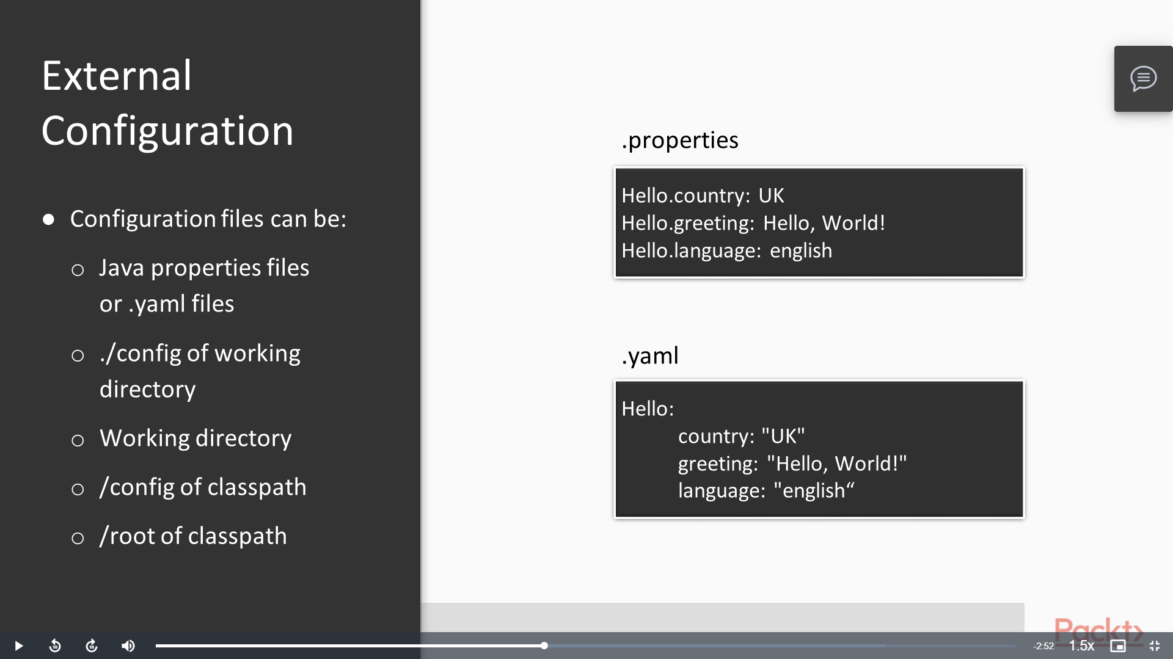

* Internal

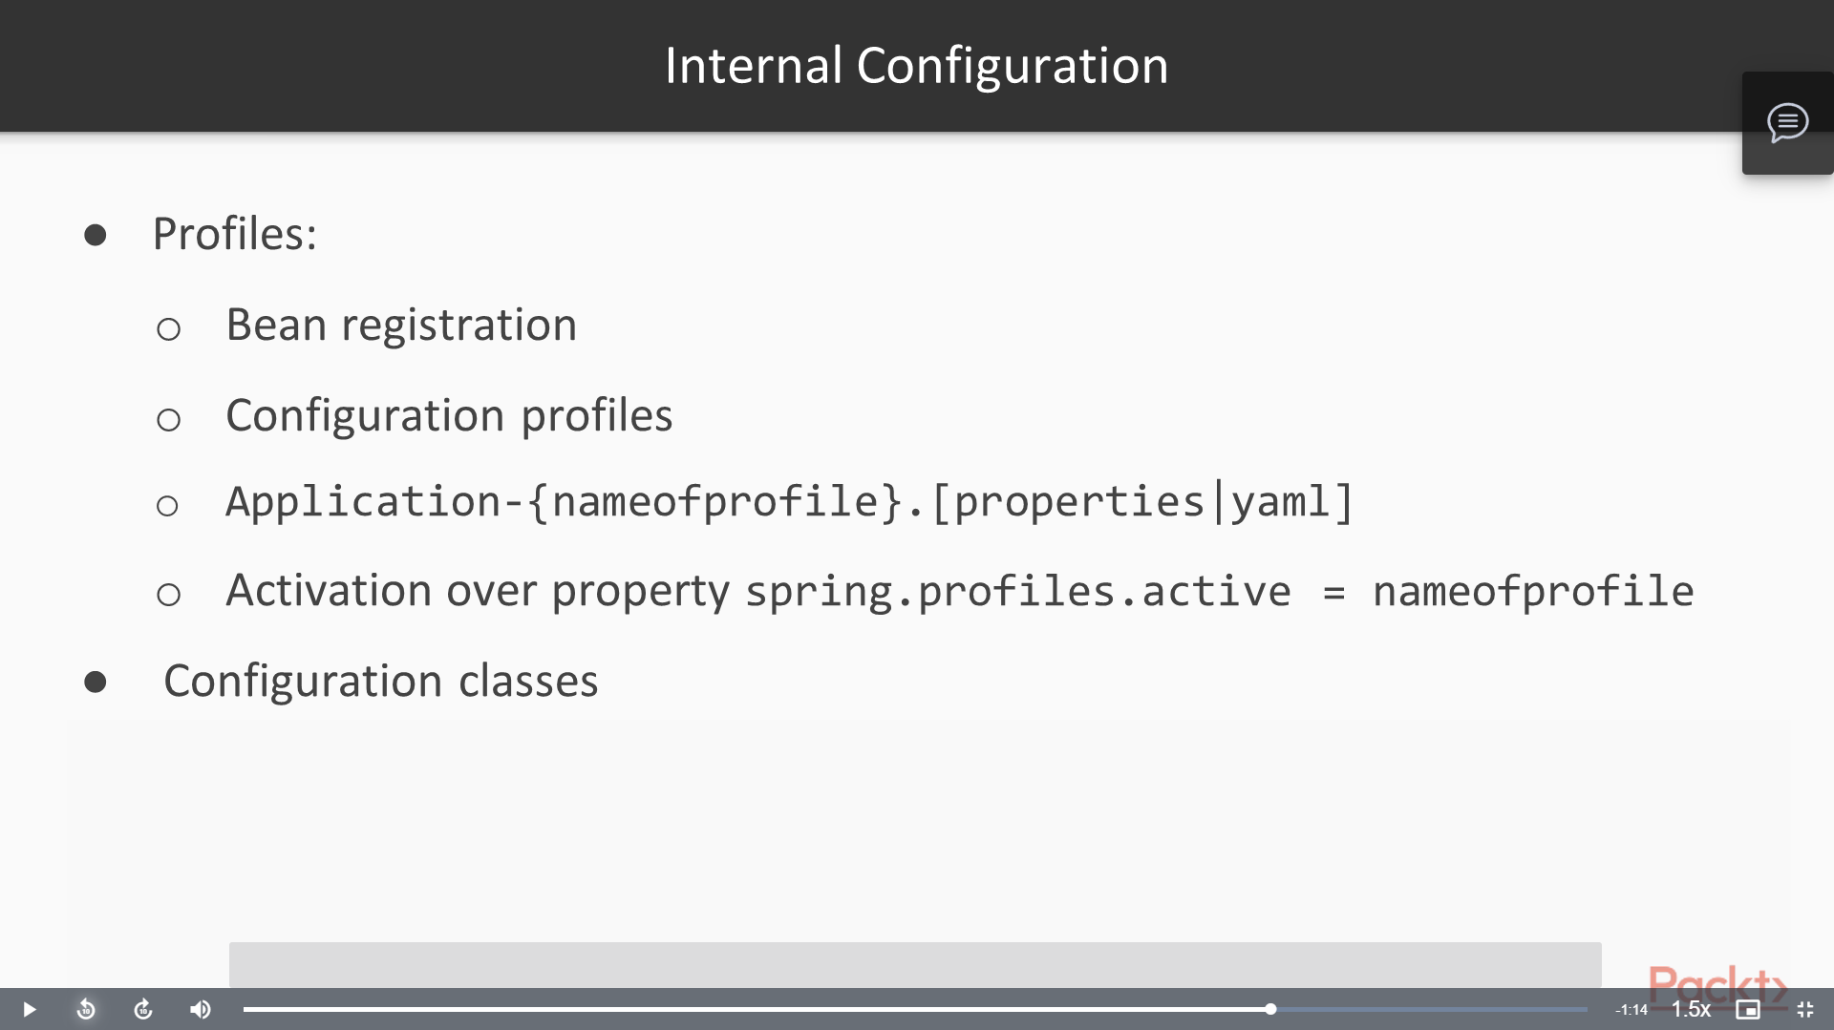

* Automatic

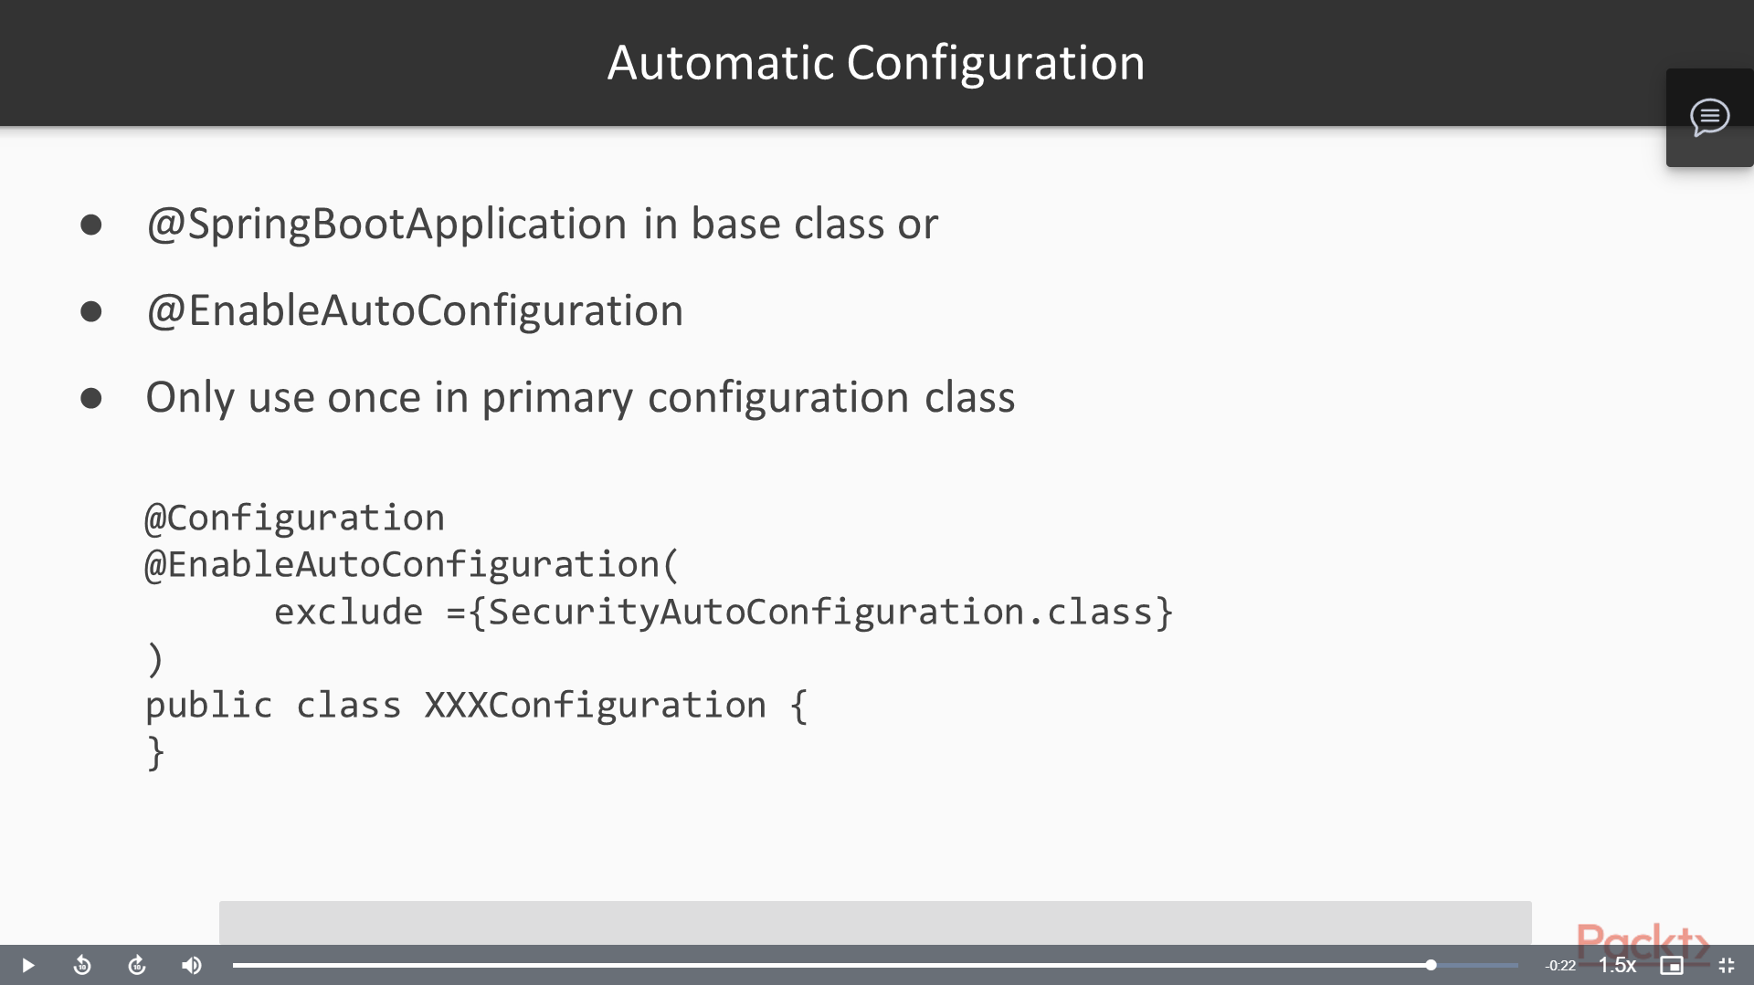

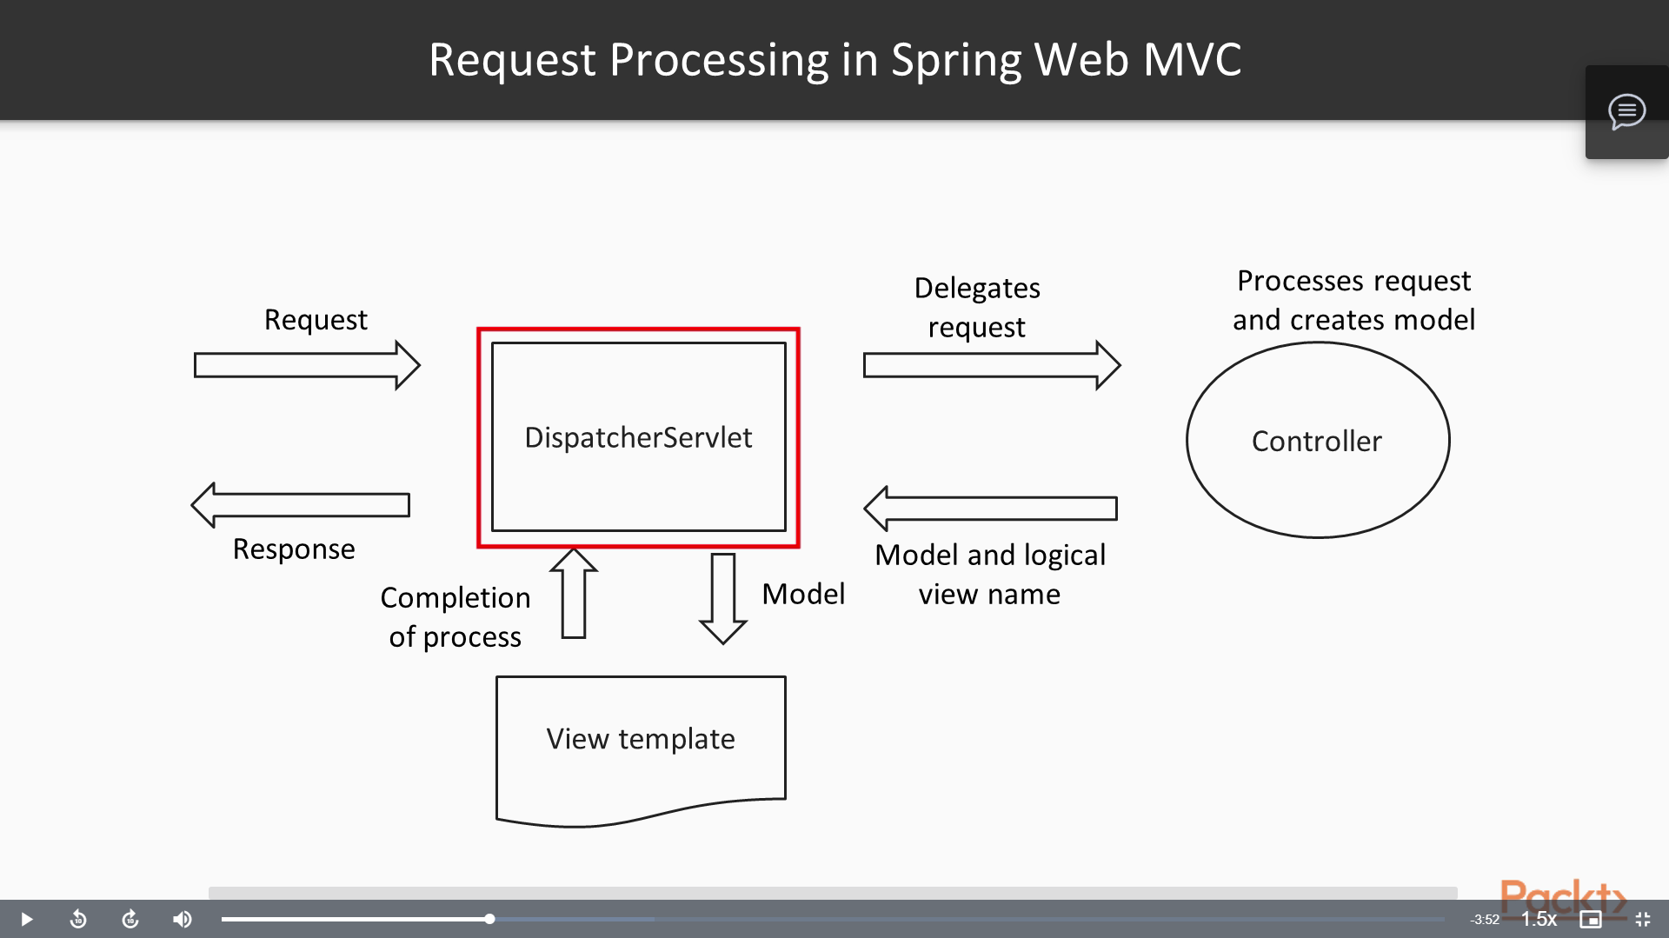

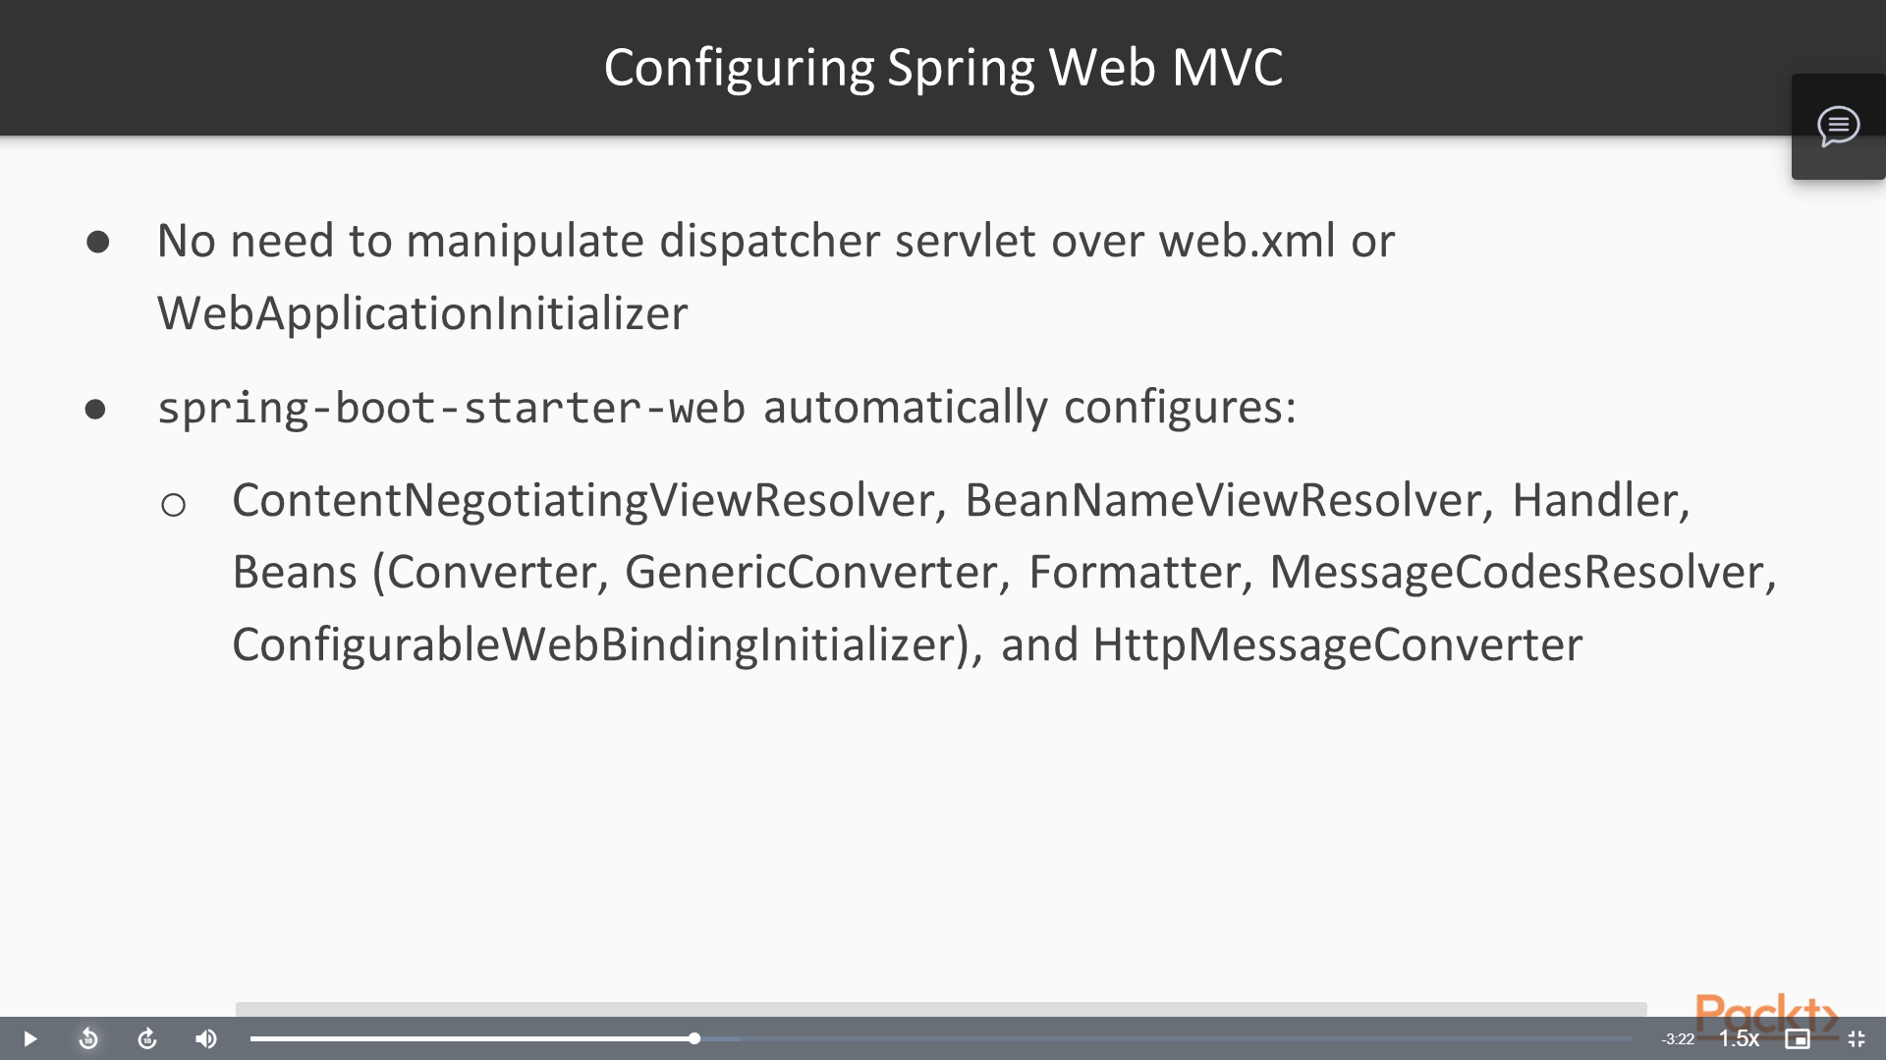

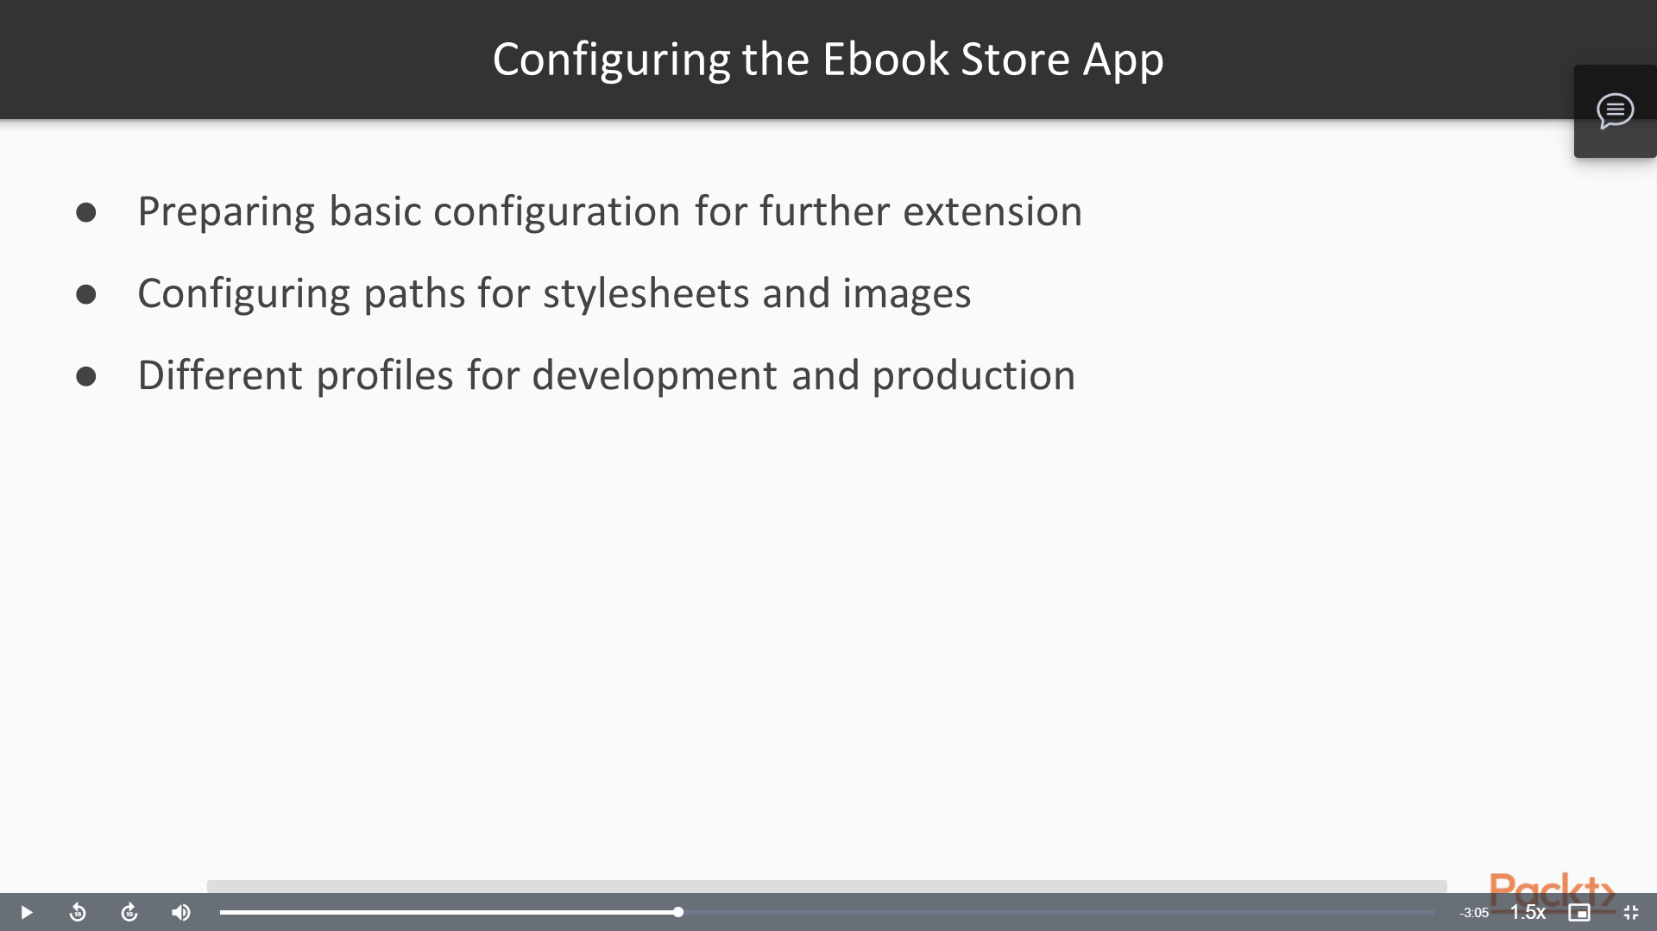

REST

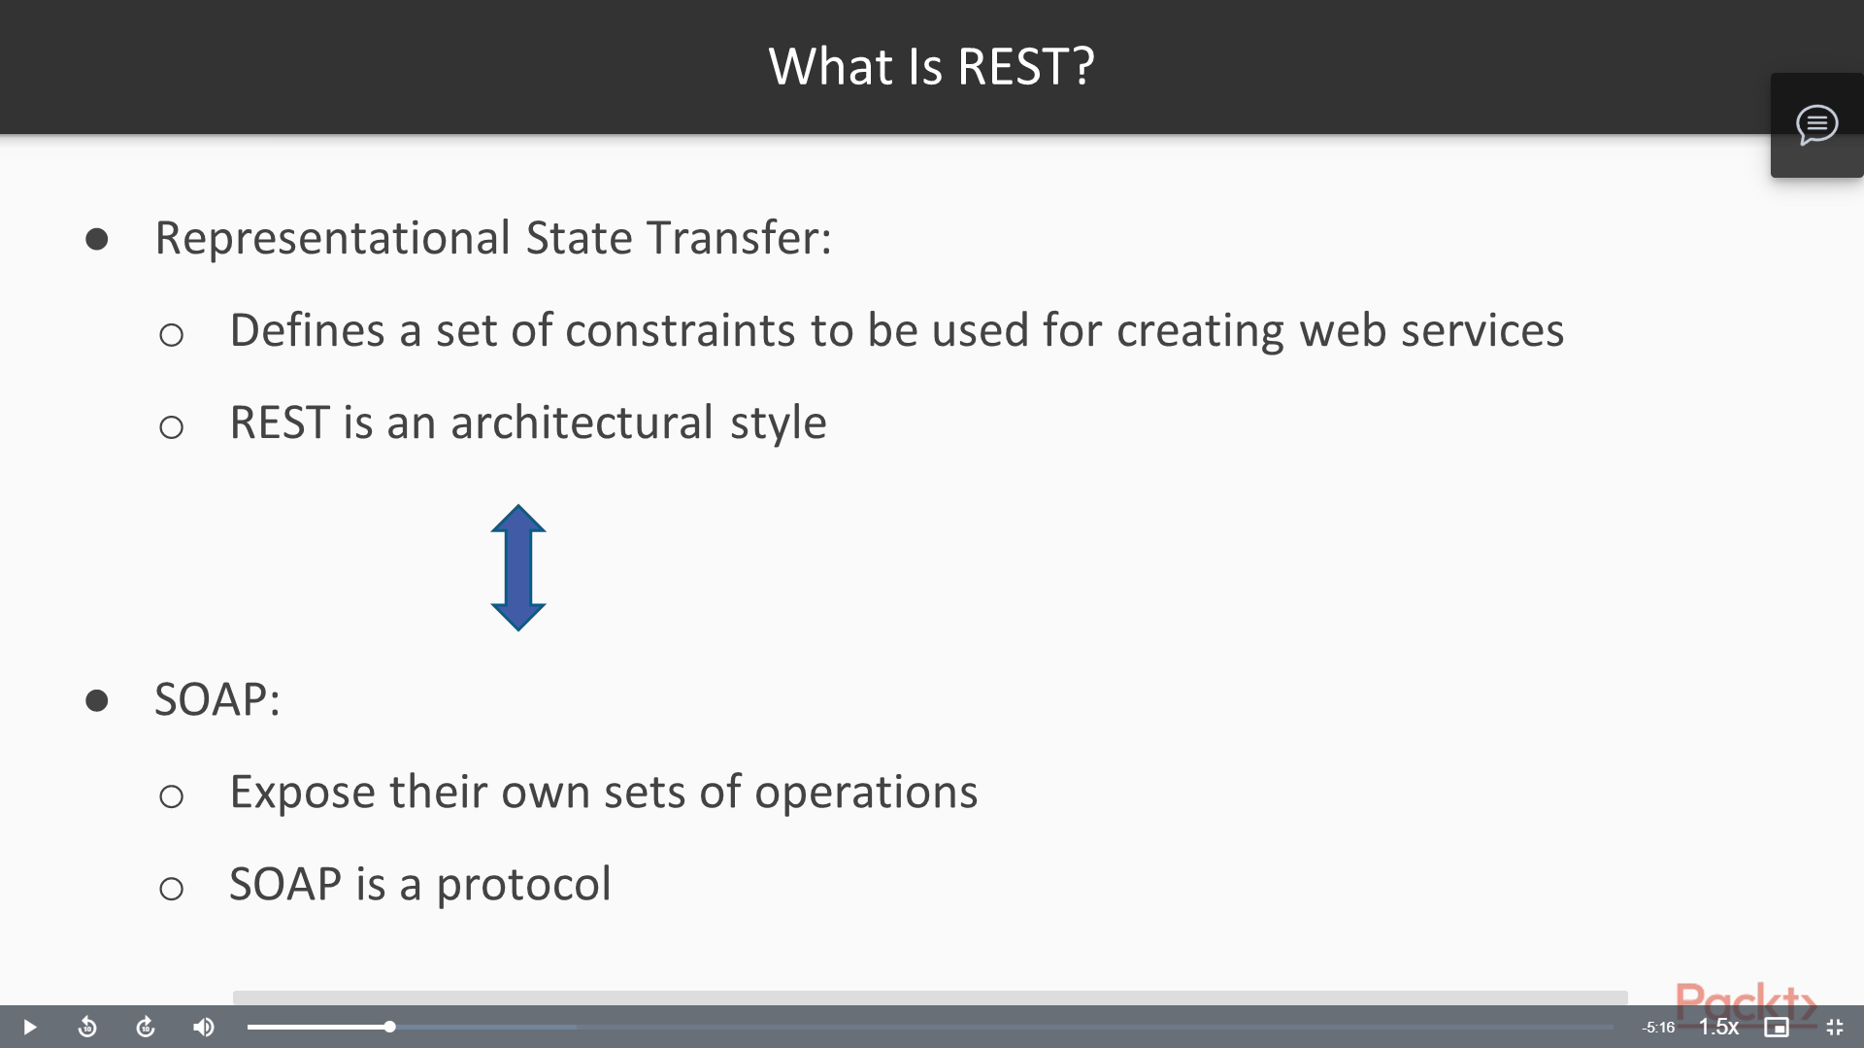

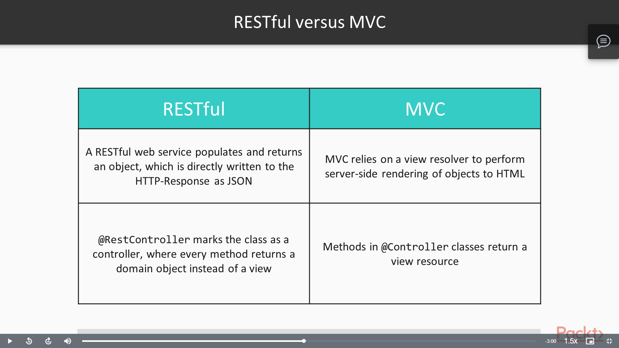

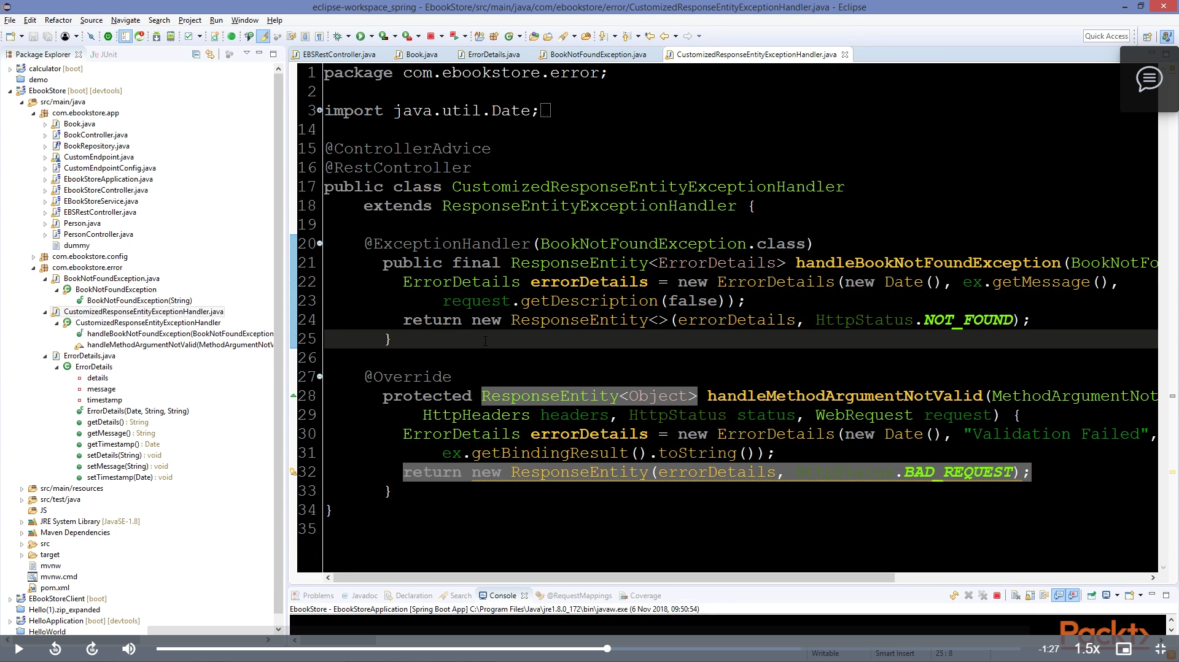

## Asynchronous & Reactive

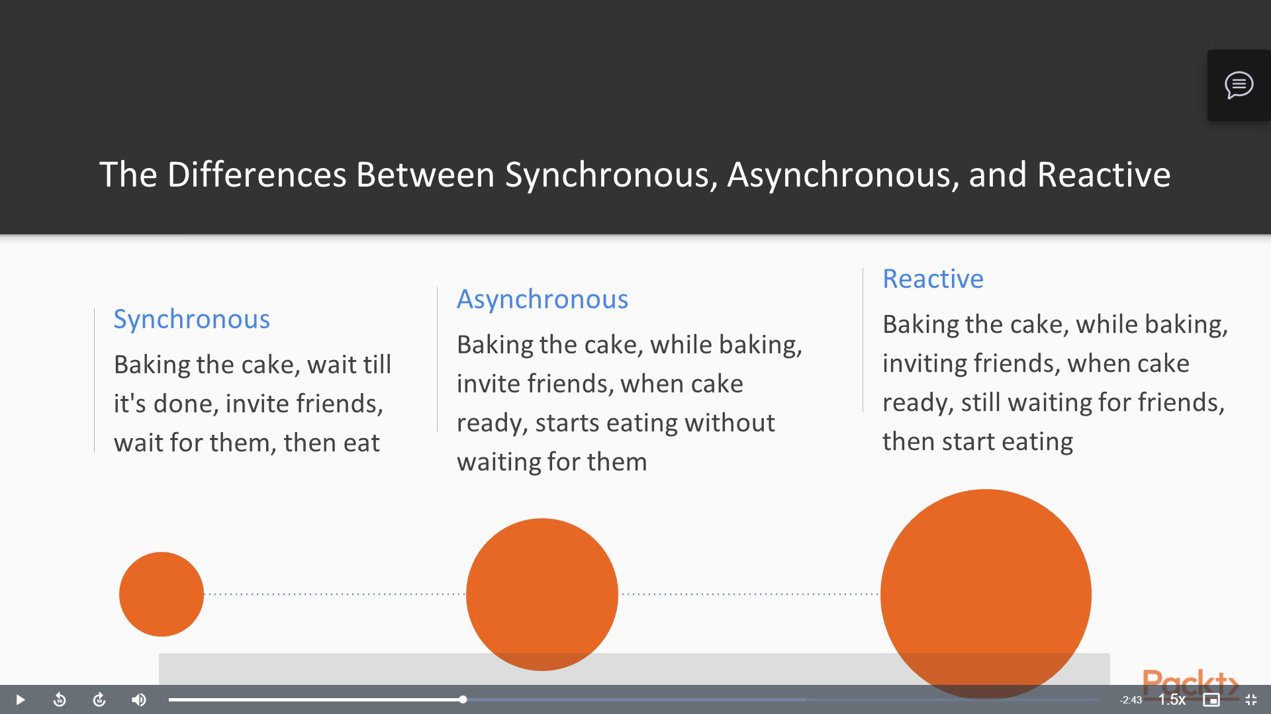

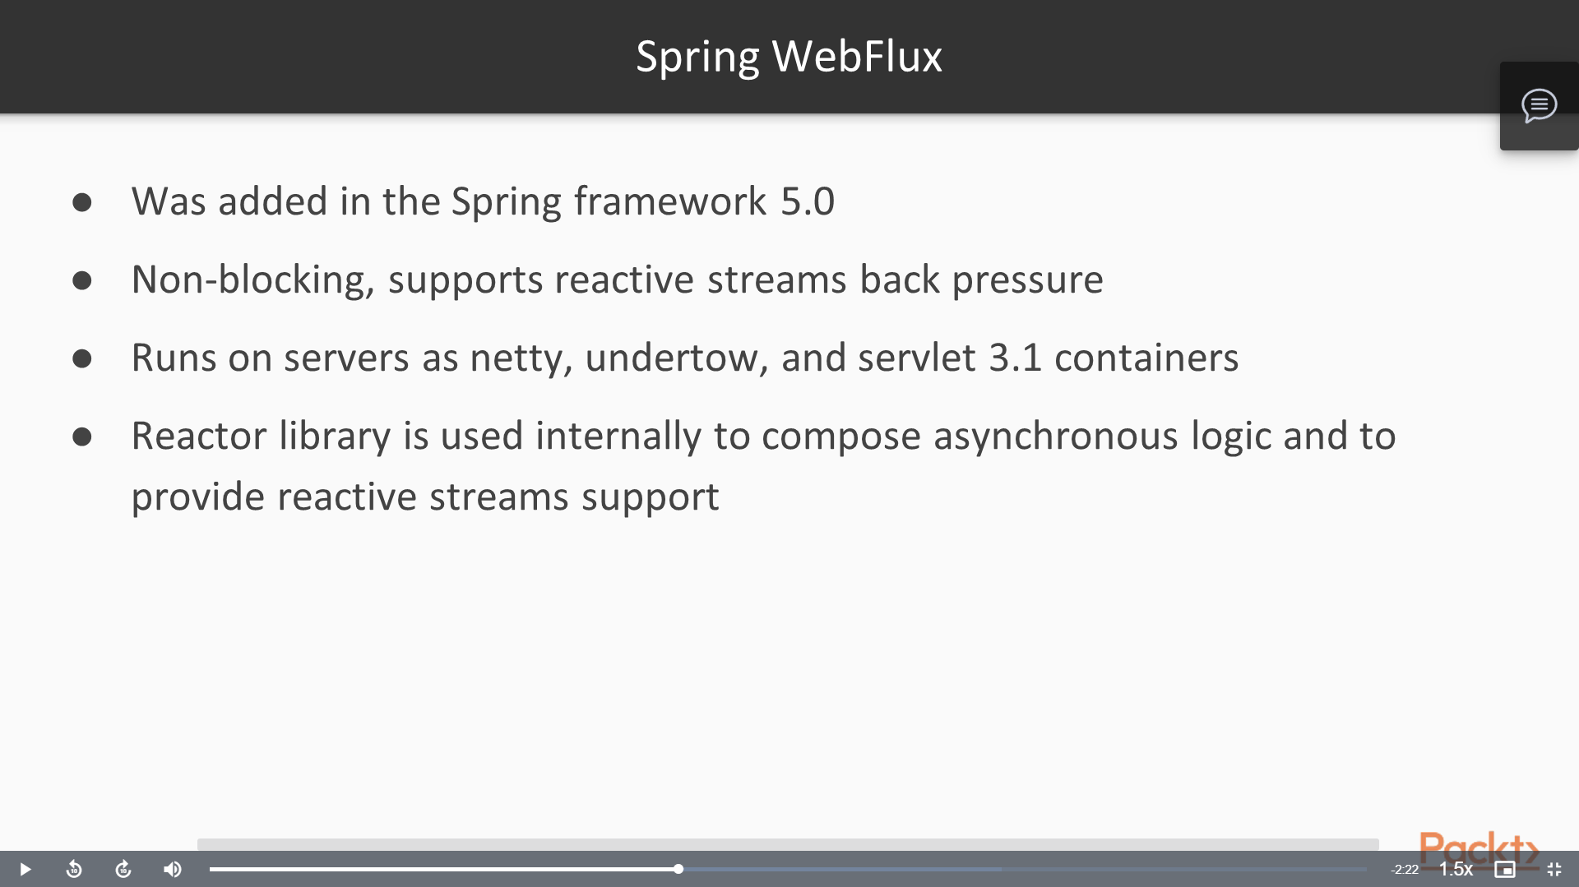

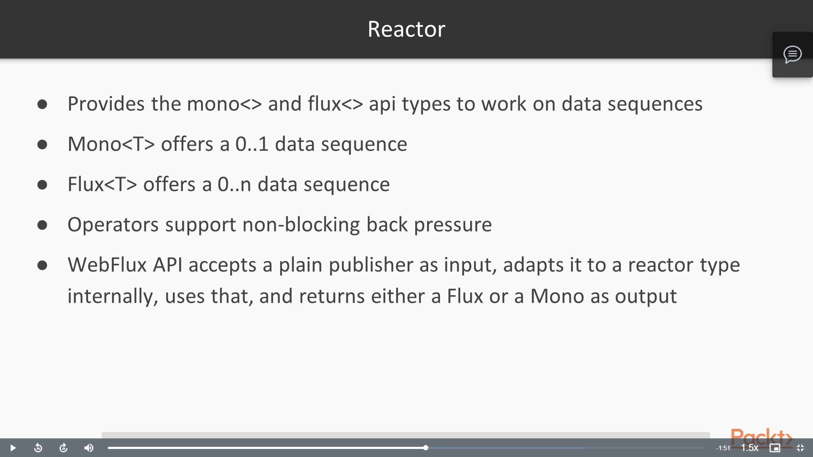

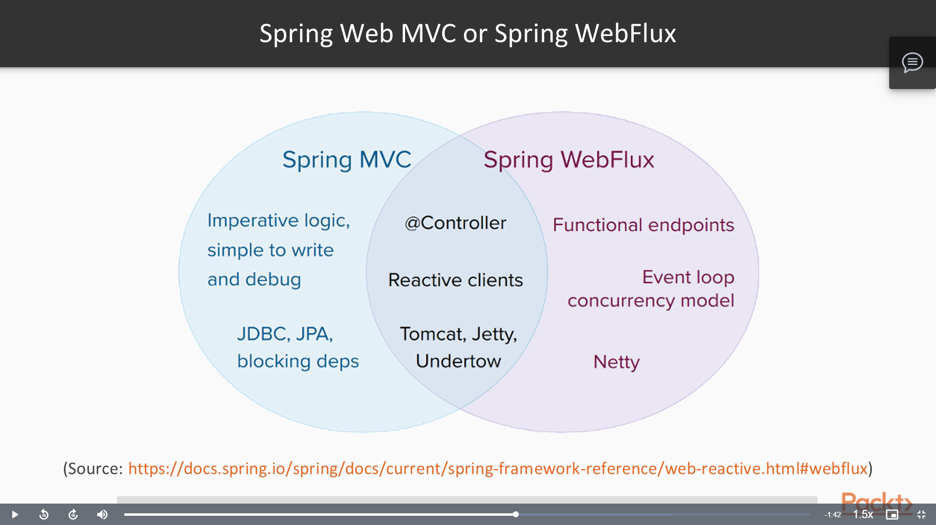

* Spring WebFlux is used for reactive approach. ReactiveMongoRepository can also be used in place of JPARepository for reactive.
* @Document is used in place of @Entity. @JsonCreator is applied above constructor with @JsonProperty inside params.
* Mono is used to return 1 object, while Flux is used to return list of objects.

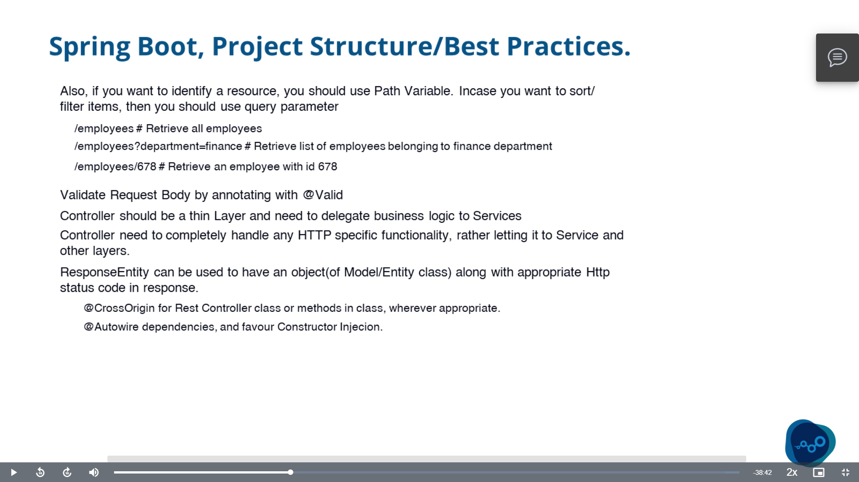

Security in spring

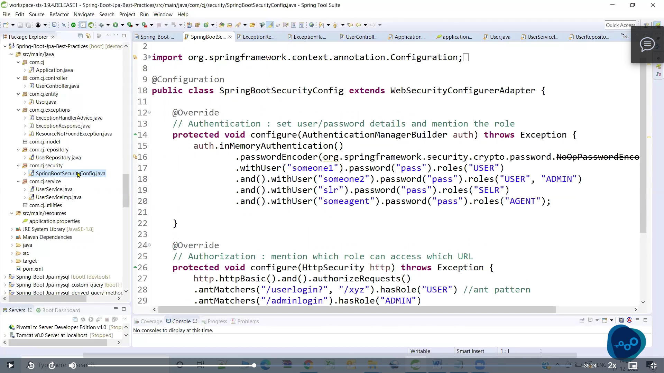

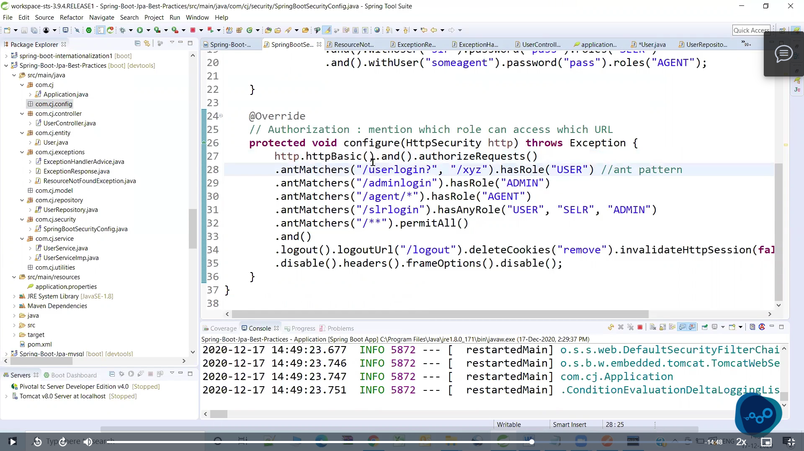

# Exception Handling

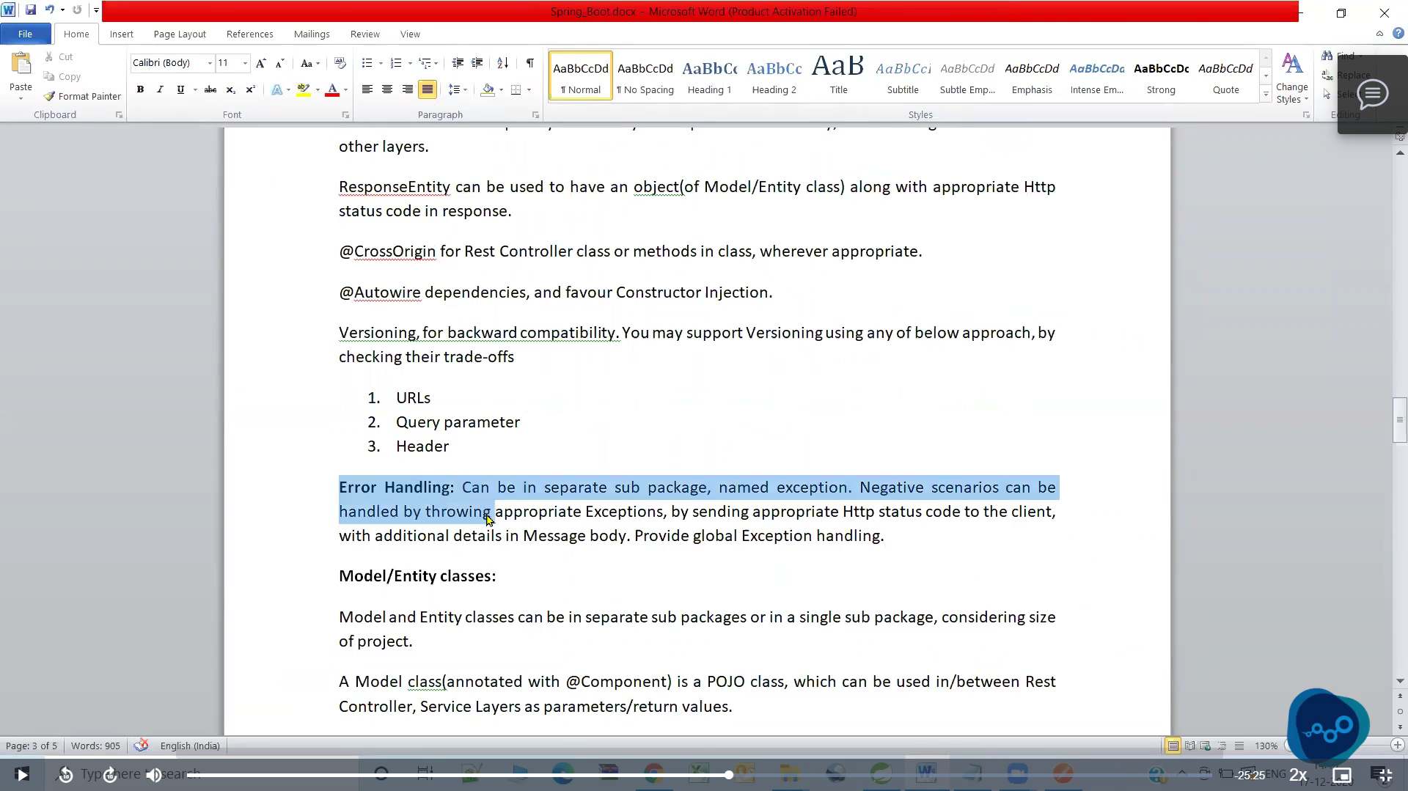

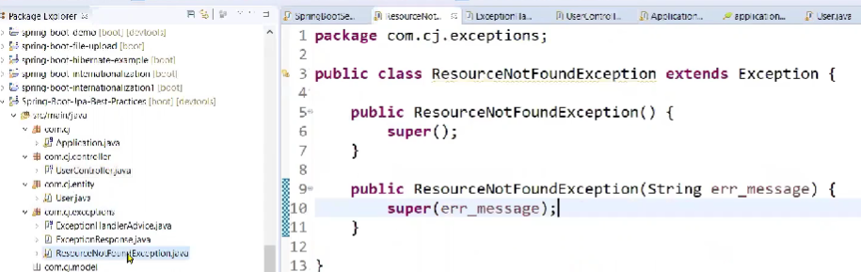

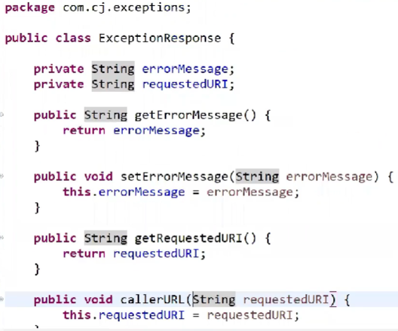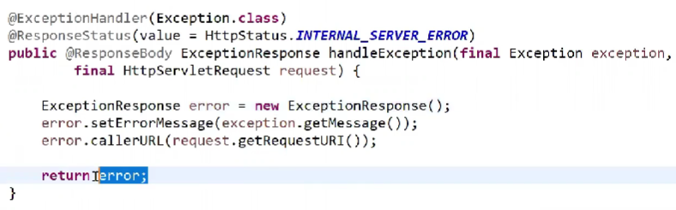

> ExceptionResponse class will inform about the details to be sent to the client when exception is thrown.

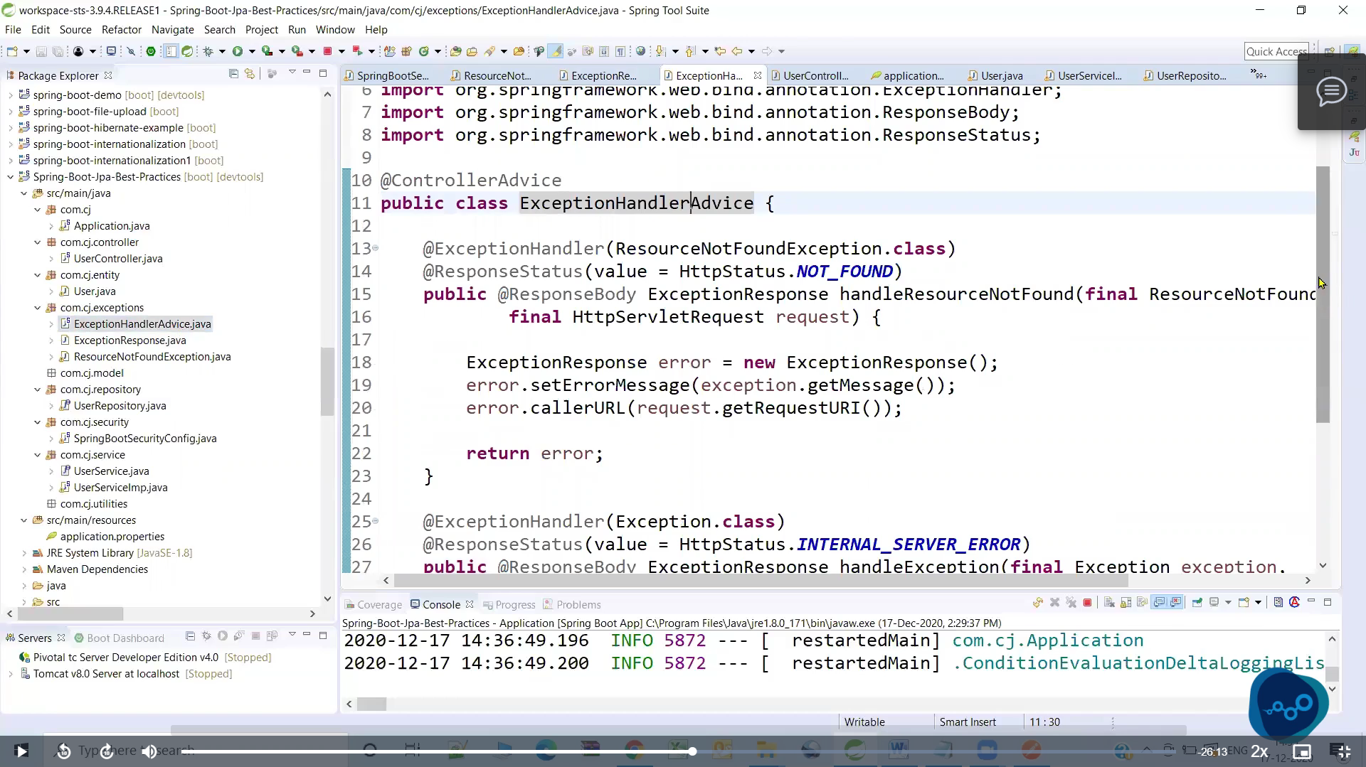

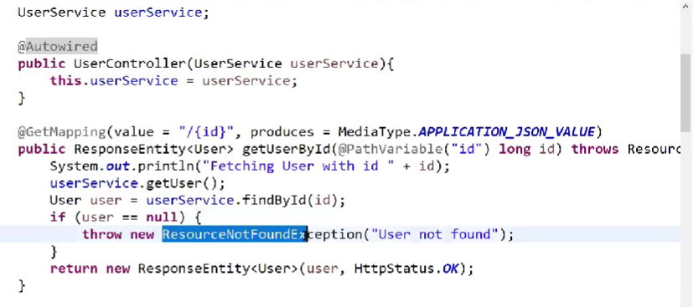

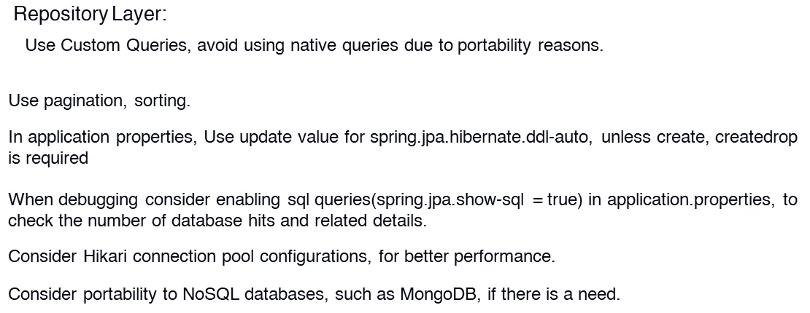

# SOLID PRINCIPLES

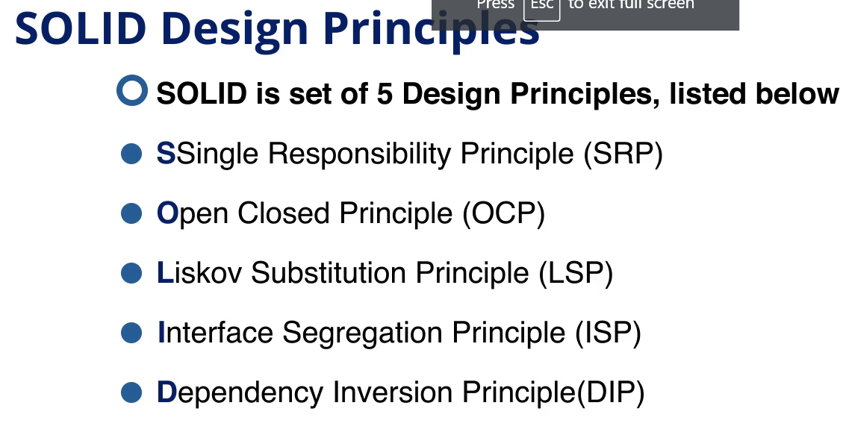

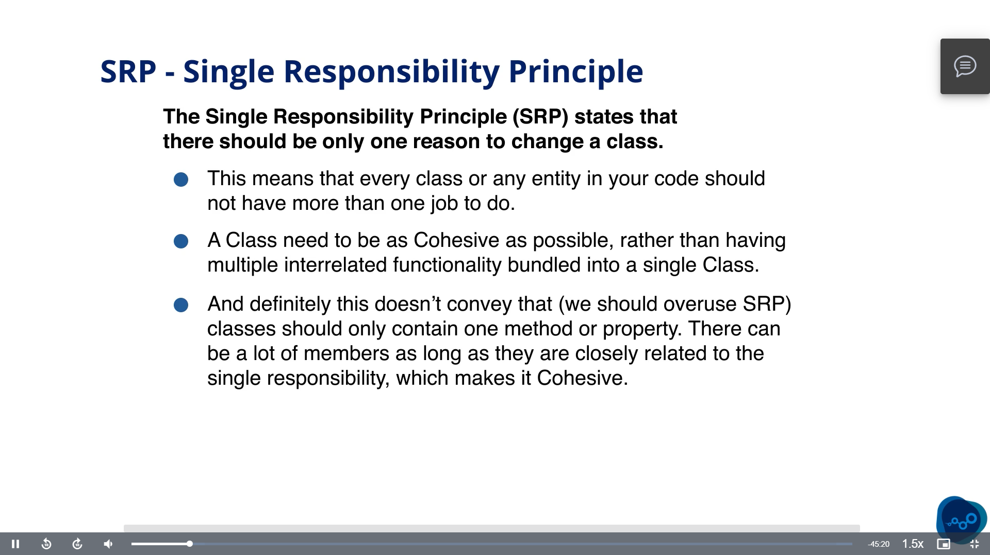

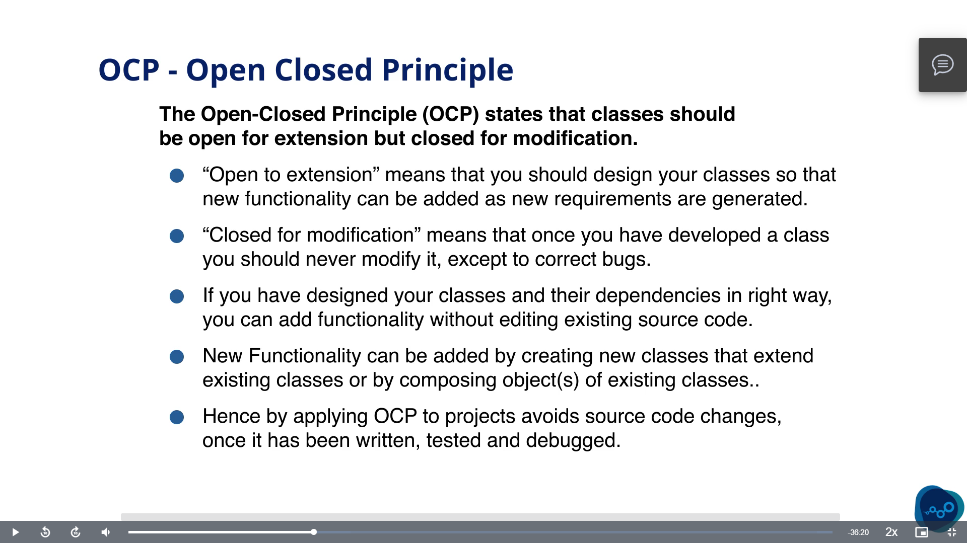

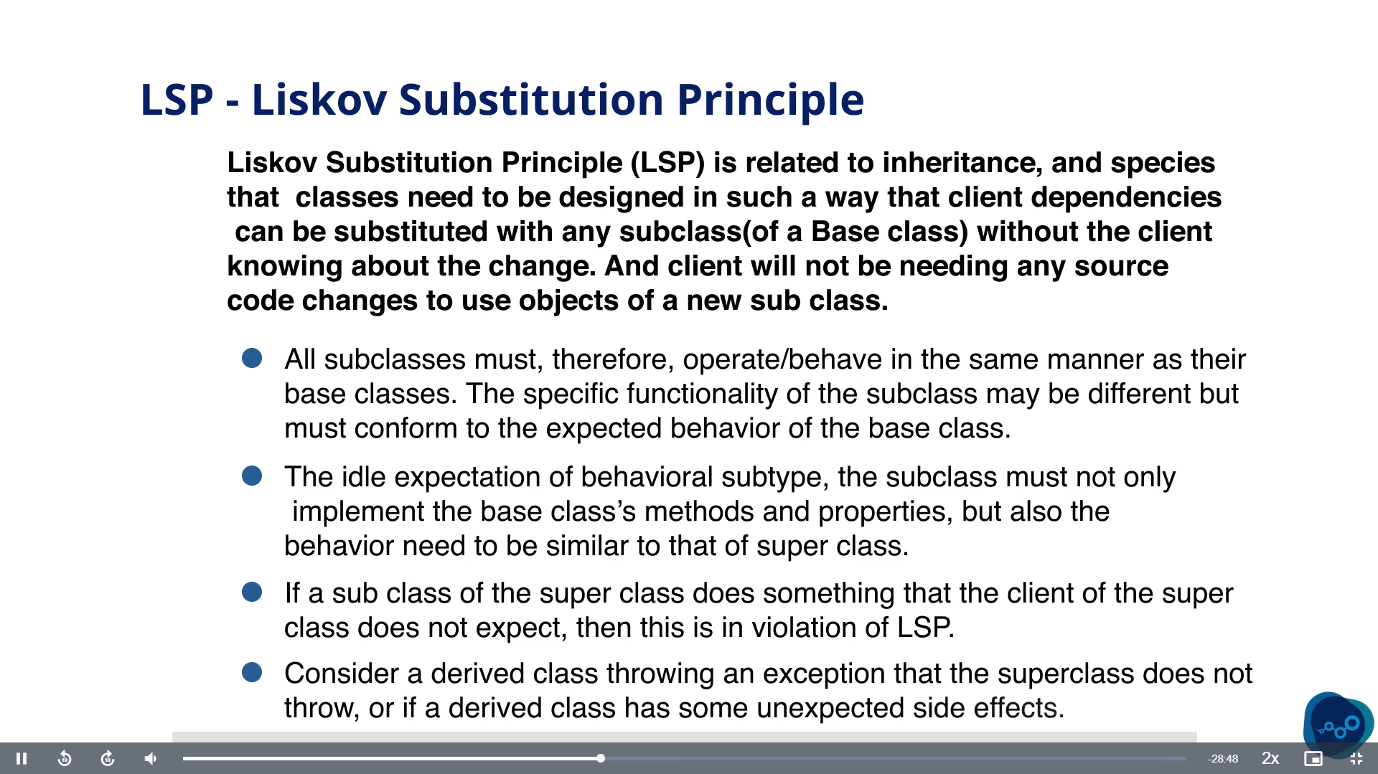

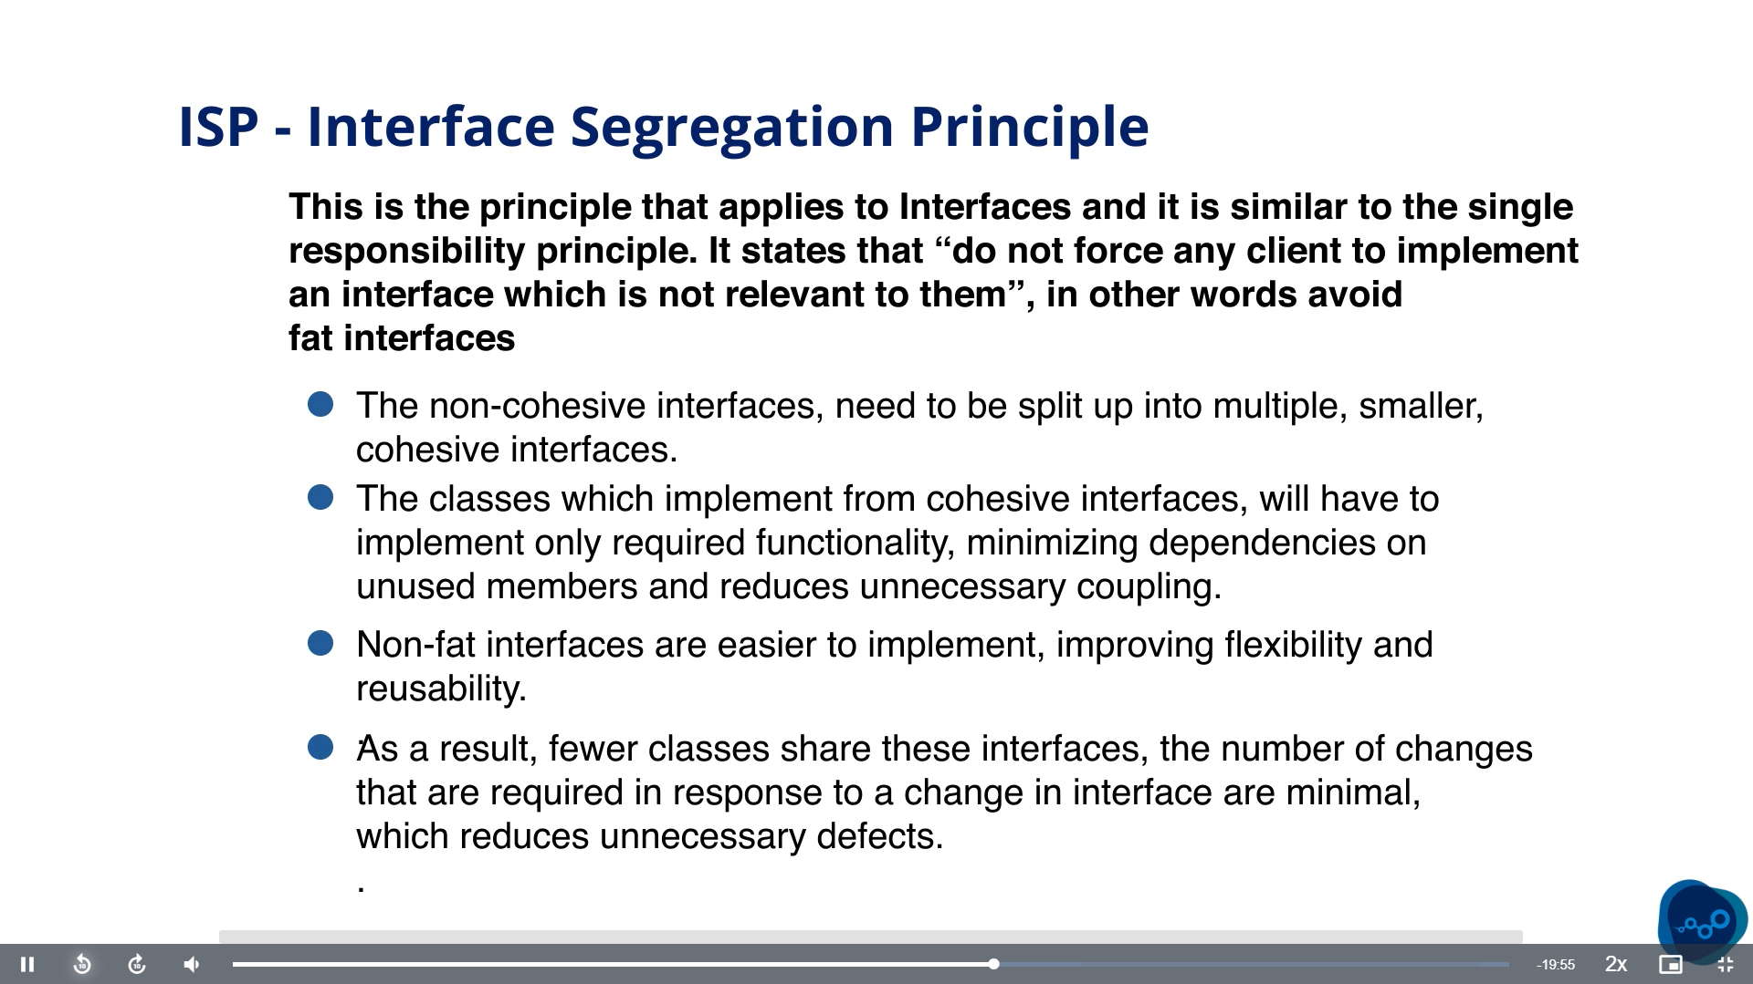

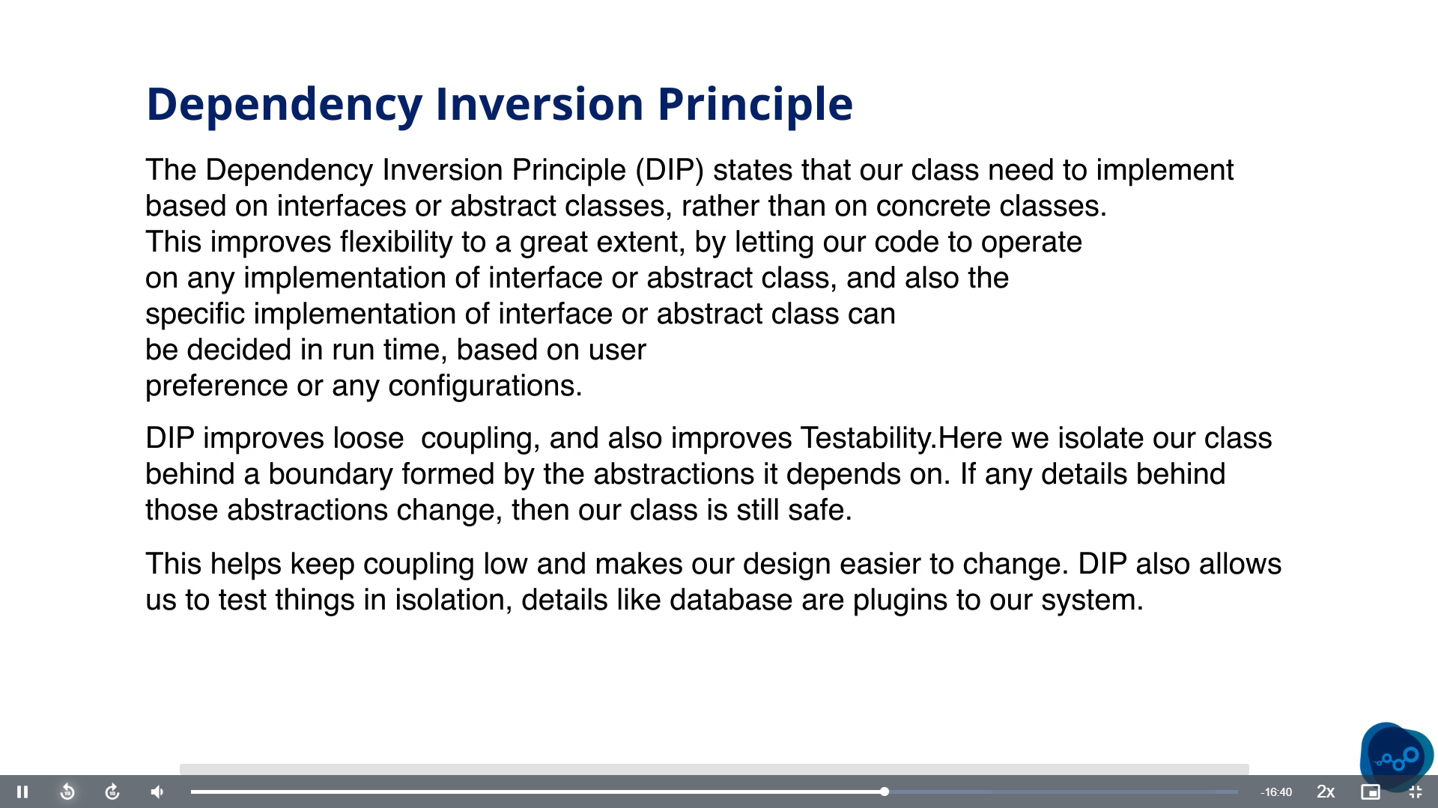

# Junit

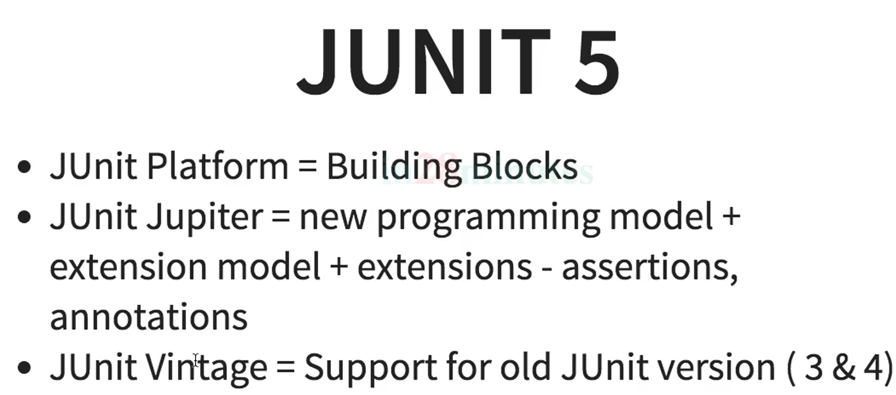

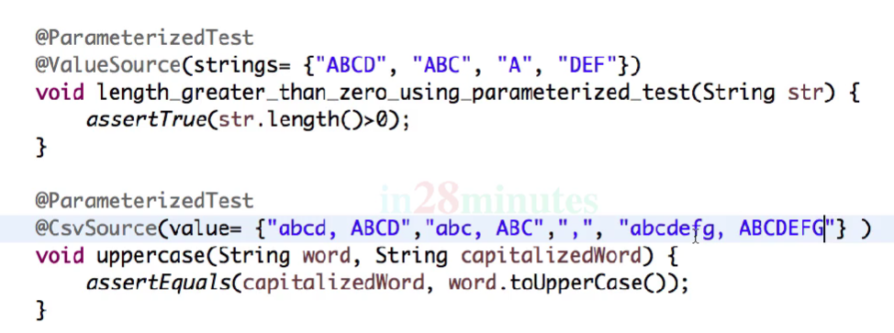

Junit4

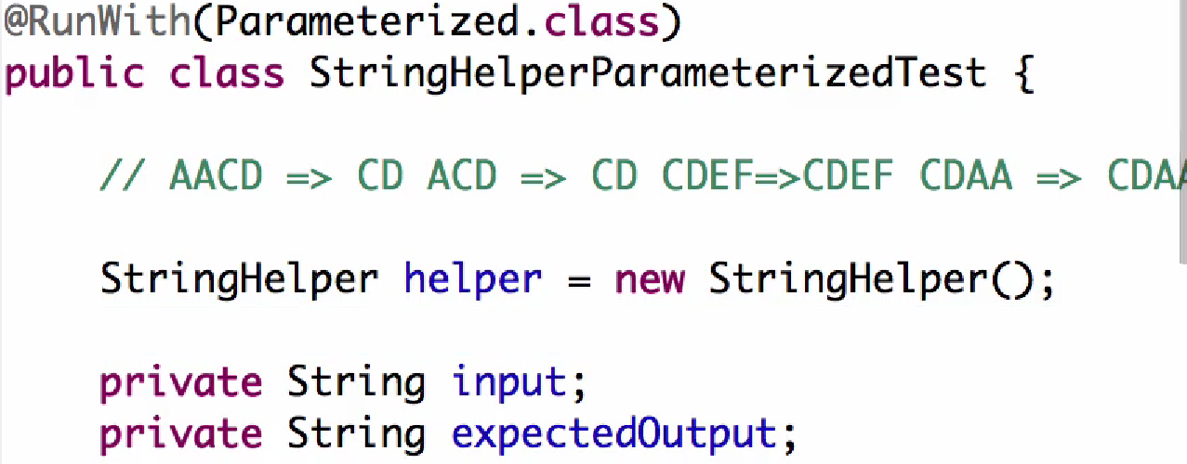

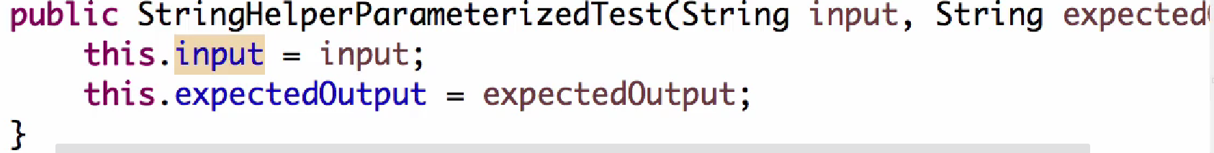

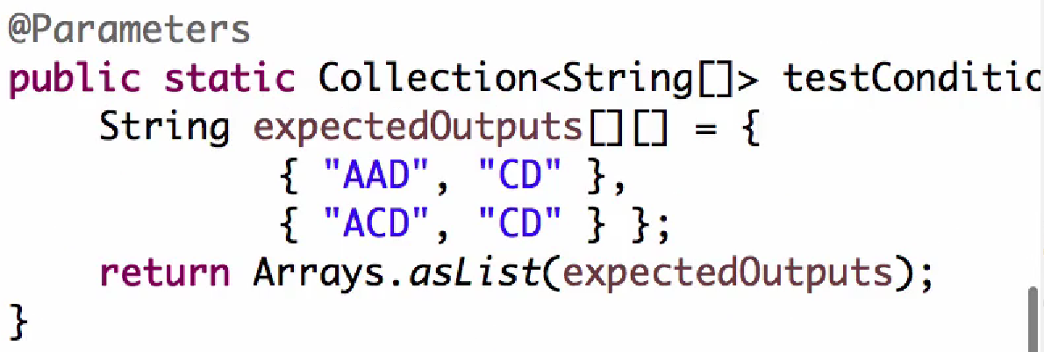

* “AAD” is input, “CD” is expected output.

Test suite in JUnit4

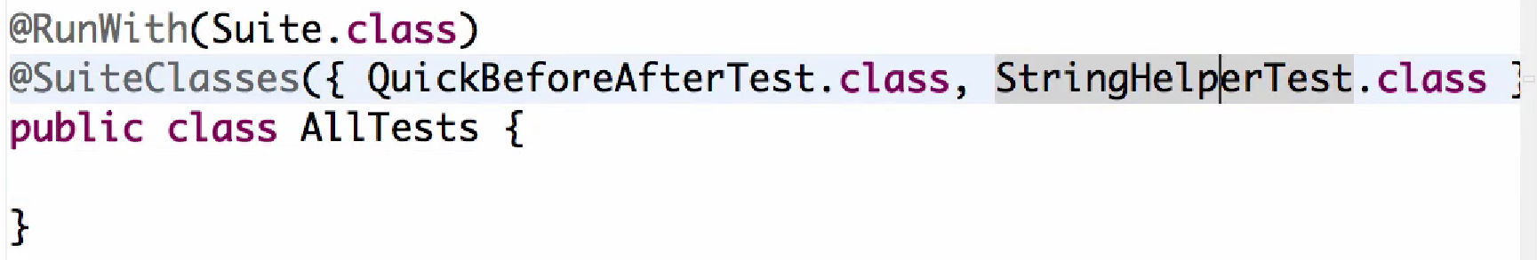

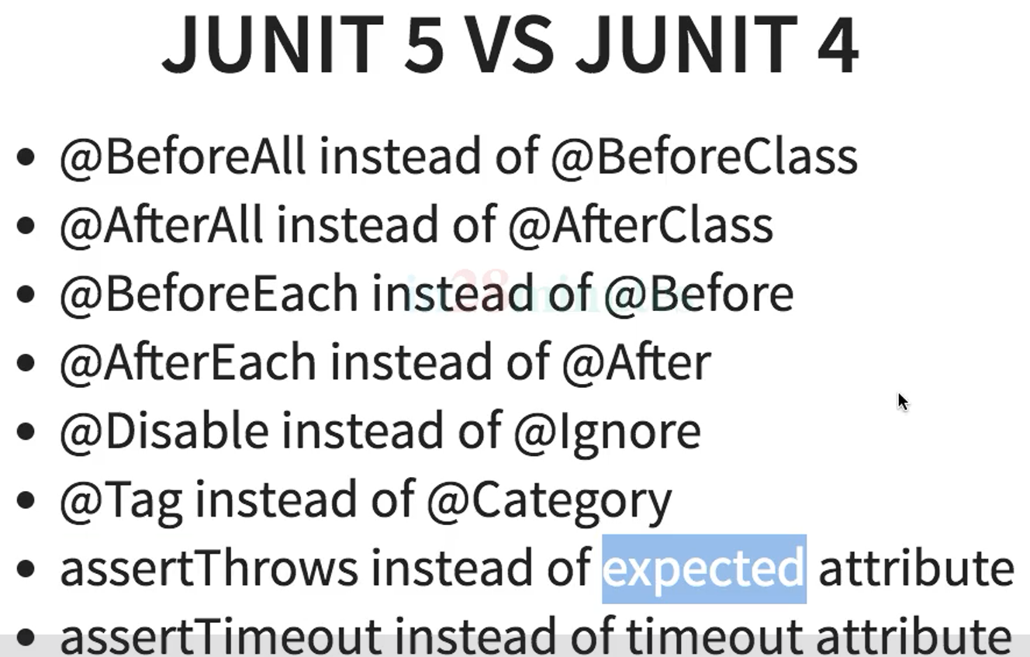

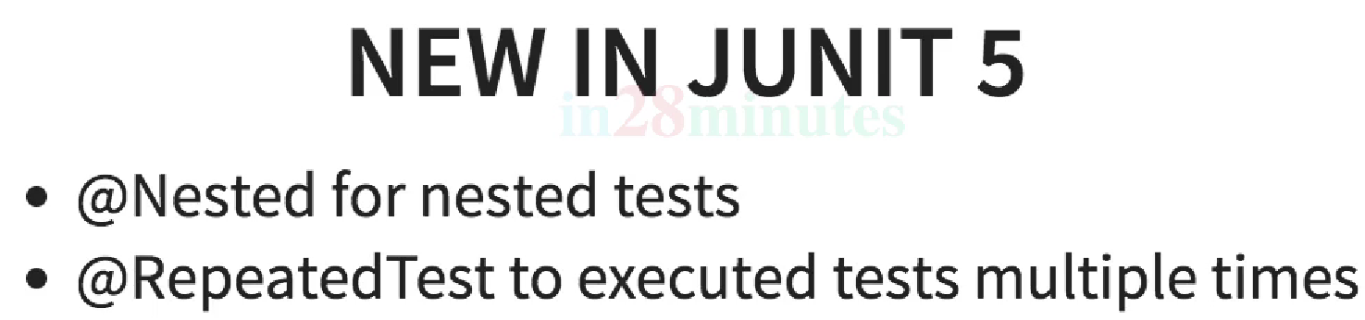

# Prometheus

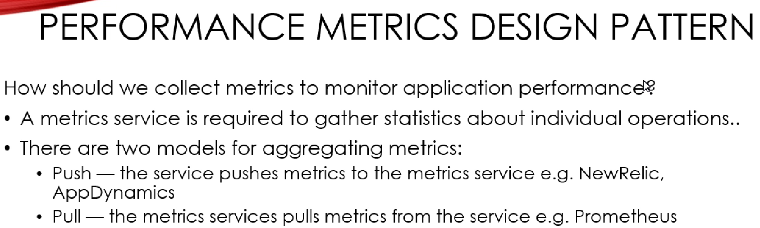

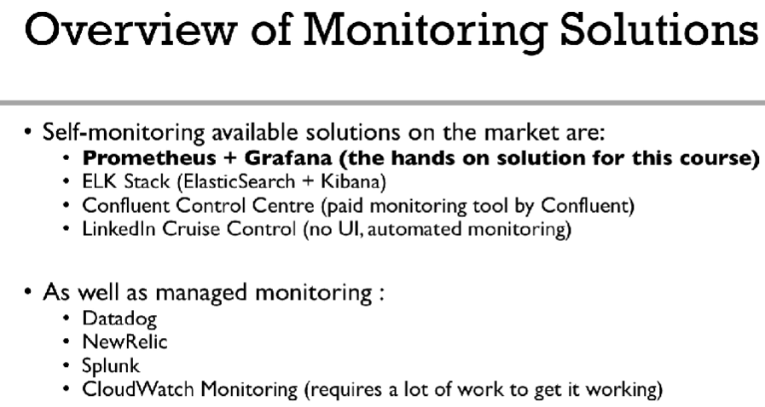

For Prometheus and Grafana, we can download the zip files from website and run the executable files or we can use docker.

For ELK stack, we can download ElasticSearch, Logstash, Kibana from the website. Then 1st run ES, 2nd run kibana, finally run logstash after modifying logstash.properties config file.

Elasticsearch is a search & analytics engine

Logstash is a server side data processing pipeline that ingest data from multiple sources simultaneously transforms the data and then sends it to a stash.

Kibana is a tool for exploration and visualisation of data

Logstash helps us to get data from multiple sources at a time. After that the fetched data is send to ElasticSearch. ES is a RESTful search & analytics engine. Kibana is an open-source visualization tool. User searches for data through kibana which is eventually sent to elasticsearch. ES transfers that search query to logstash which searches all different log files for that data which returns back to ES and eventually gets displayed in Kibana.

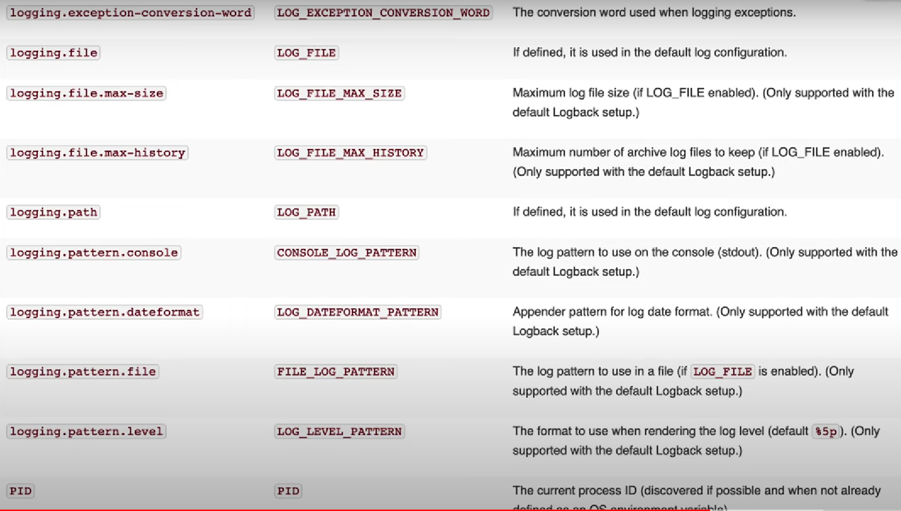

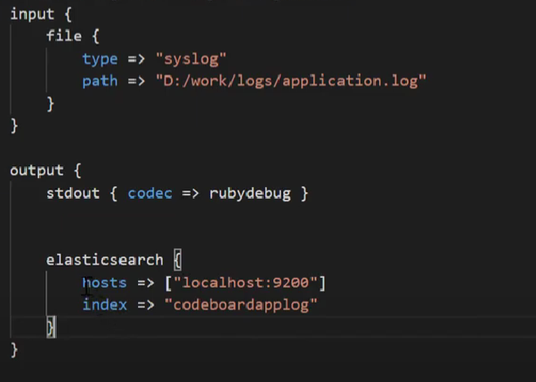

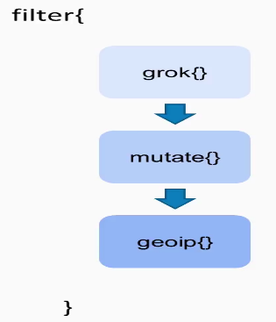 For logstash, filter is used to filter logs from log-source file. mutate() is used to edit or modify the logs.

grok() plugin is used for pasing unstructured data to structured data. It makes data easily queryable/filterable. Eg:

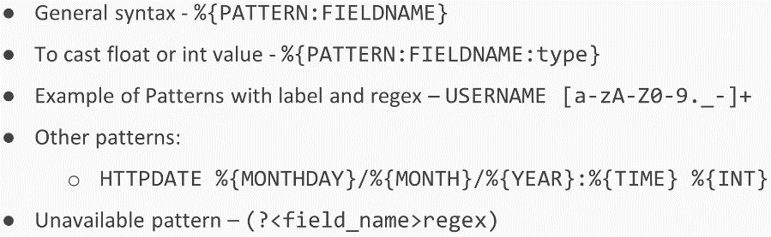

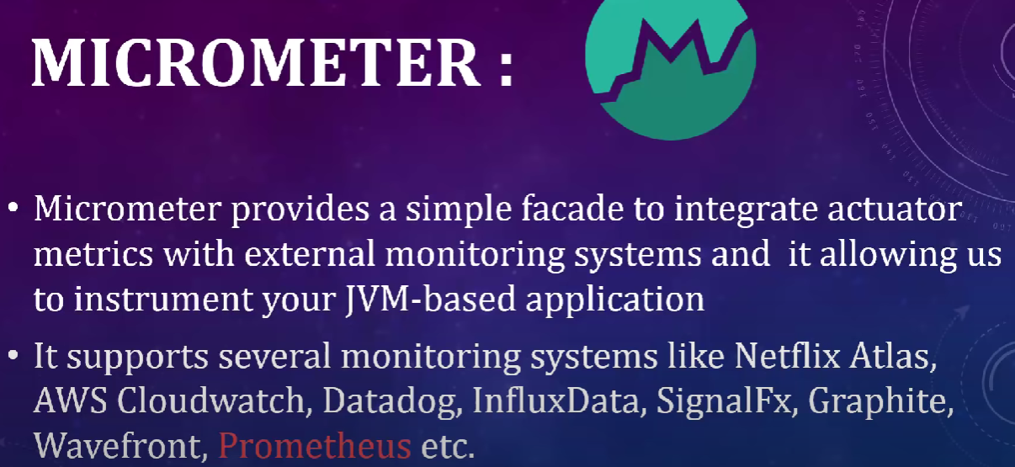

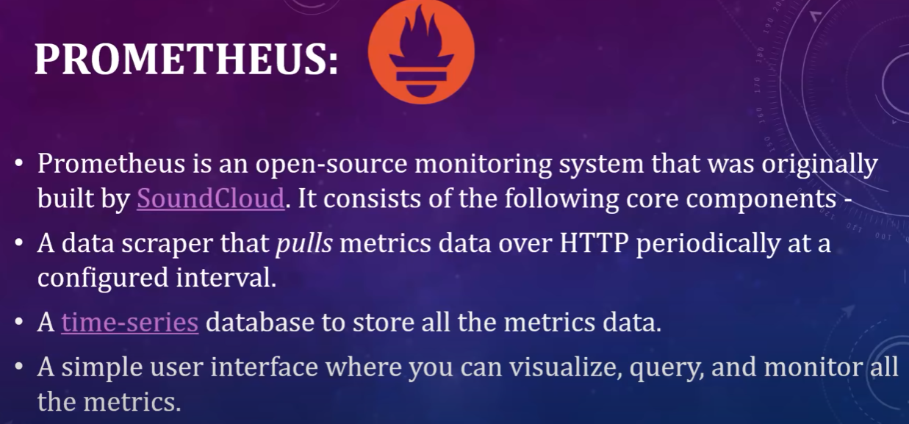

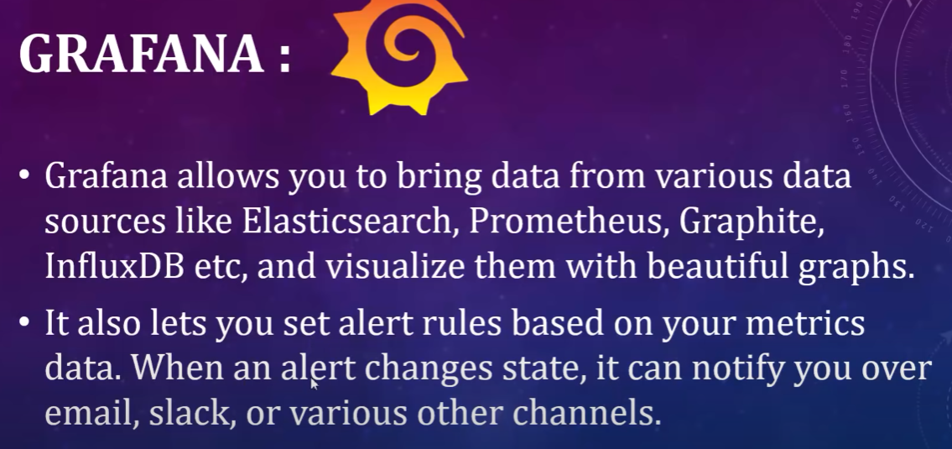

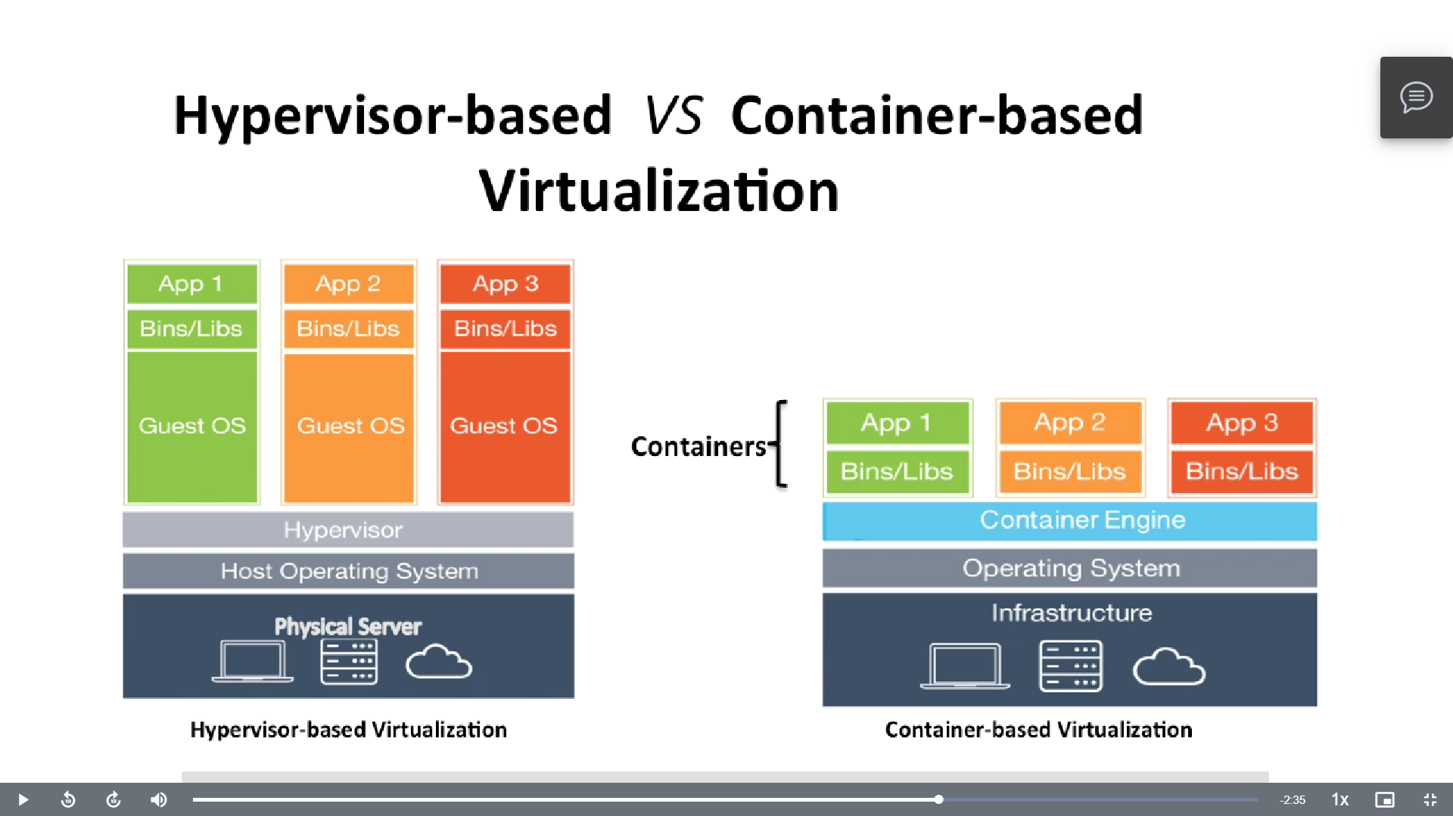

# Spring security

WebSecurityConfigurerAdapter= by overriding its methods we can change the default configuration of spring security.

Configure(Http) = we configure here which urls to permit, i.e., which urls will be allowed after authentication / without auth.

configure(auth) = here we specify what type of authentication we want to use like in-memory, jdbc, userdetails.

* Create a custom UserDetailsService class that overrides loadUserByUserName(). Here we implement the logic to check whether user with that username is present and if present then we return the username and password.
* Create a JwtUtil class that contains all methods for Jwt related tokens.
* Inside controller, create an authentication object(i.e., UsernamePasswordAuthenticationToken) with username & password.
* Check whether username is present or not by authenticating using authenticationManager(Process an authentication request).
* If present load user by username & store it in UserDetails.
* Create jwt token using UserDetails for that username.
* Now we have to check whether token is valid or not.
  + For that, we will extend a class with OncePerRequestFilter. We will override the dofilter()
  + This method will validate the jwt token send to authenticate the requests.
  + Here, we will create usernamePasswordAuthenticationToken then we will create WebAuthenticationDetails().
  + WebAuthenticationDetails is a holder of selected Http details related to a web authentication request.
  + An authentication implementation that is designed for simple presentation of a username & password.
  + Inside token, we will set the web auth details.
* **Spring Security**
* – [WebSecurityConfigurerAdapter](https://docs.spring.io/spring-security/site/docs/current/api/org/springframework/security/config/annotation/web/configuration/WebSecurityConfigurerAdapter.html) is the crux of our security implementation. It provides [HttpSecurity](https://docs.spring.io/spring-security/site/docs/current/reference/htmlsingle/#jc-httpsecurity) configurations to configure cors, csrf, session management, rules for protected resources. We can also extend and customize the default configuration that contains the elements below.
* – [UserDetailsService](https://docs.spring.io/spring-security/site/docs/current/reference/htmlsingle/#tech-userdetailsservice) interface has a method to load User by username and returns a UserDetails object that Spring Security can use for authentication and validation.
* – UserDetails contains necessary information (such as: username, password, authorities) to build an Authentication object.
* – [UsernamePasswordAuthenticationToken](https://docs.spring.io/spring-security/site/docs/current/api/org/springframework/security/authentication/UsernamePasswordAuthenticationToken.html) gets {username, password} from login Request, AuthenticationManager will use it to authenticate a login account.
* – [AuthenticationManager](https://docs.spring.io/spring-security/site/docs/current/reference/htmlsingle/#core-services-authentication-manager) has a DaoAuthenticationProvider (with help of UserDetailsService & PasswordEncoder) to validate UsernamePasswordAuthenticationToken object. If successful, AuthenticationManager returns a fully populated Authentication object (including granted authorities).
* – [OncePerRequestFilter](https://docs.spring.io/spring-framework/docs/current/javadoc-api/org/springframework/web/filter/OncePerRequestFilter.html) makes a single execution for each request to our API. It provides a doFilterInternal() method that we will implement parsing & validating JWT, loading User details (using UserDetailsService), checking Authorizaion (using UsernamePasswordAuthenticationToken).
* – [AuthenticationEntryPoint](https://docs.spring.io/spring-security/site/docs/current/api/org/springframework/security/web/AuthenticationEntryPoint.html) will catch authentication error.